Math 8

Unit 10
Pythagorean Theorem

Name: ______________

Class Period: ___

Teacher: _________

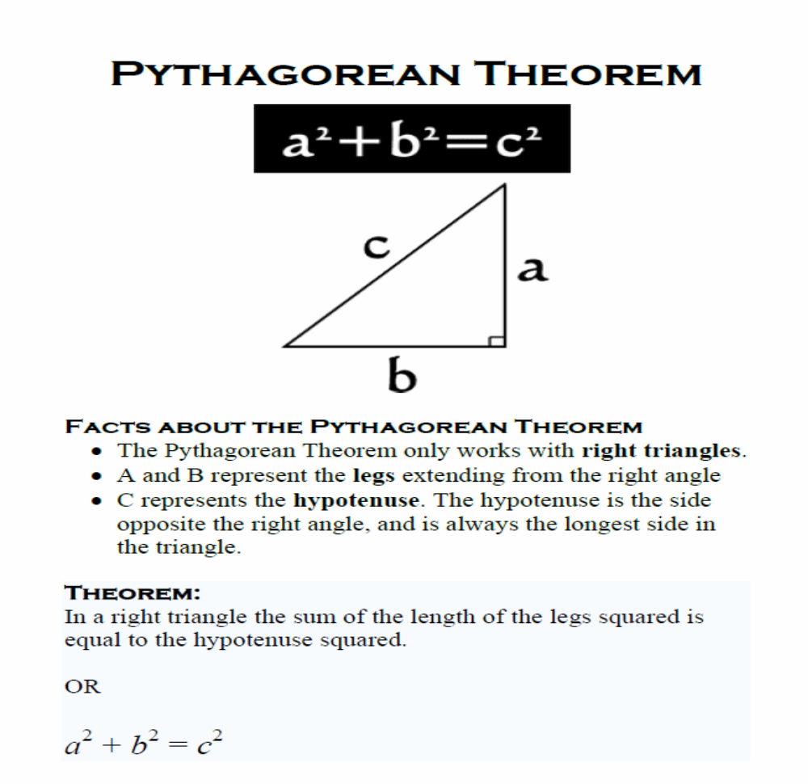

Copy and complete the table below. The numbers in the bottom row are called “perfect squares”:
Number | 0 | 1 | 2 | 3 | 4 | 5 | 6 | 7 | 8 | 9 | 10 | 11 | 12 | 13 | 14 | 15 | 16 | 17 | 18 | 19 | 20
Its Square |  | 1 | 4 | 9 |  | 25 |  |  |  |  | 100

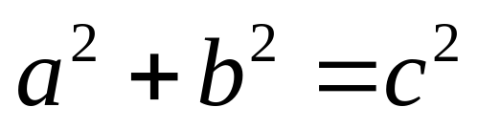

a²

b²

c²

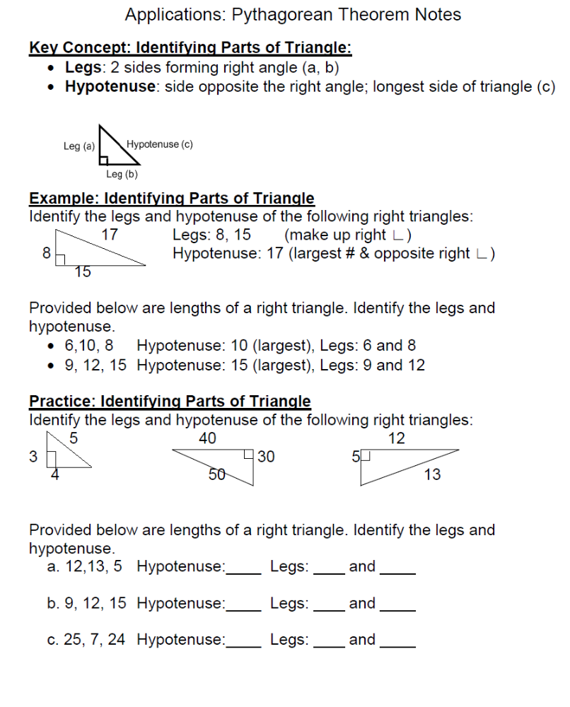


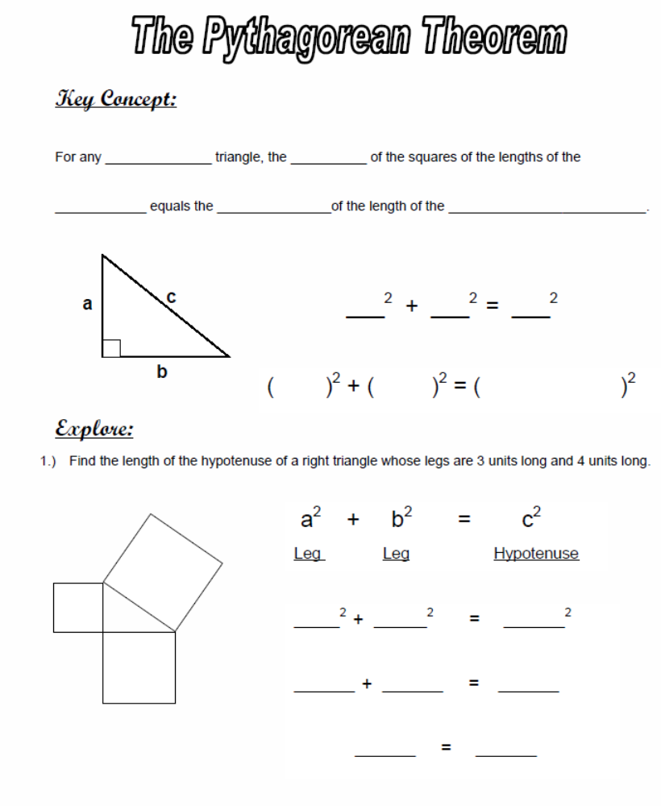

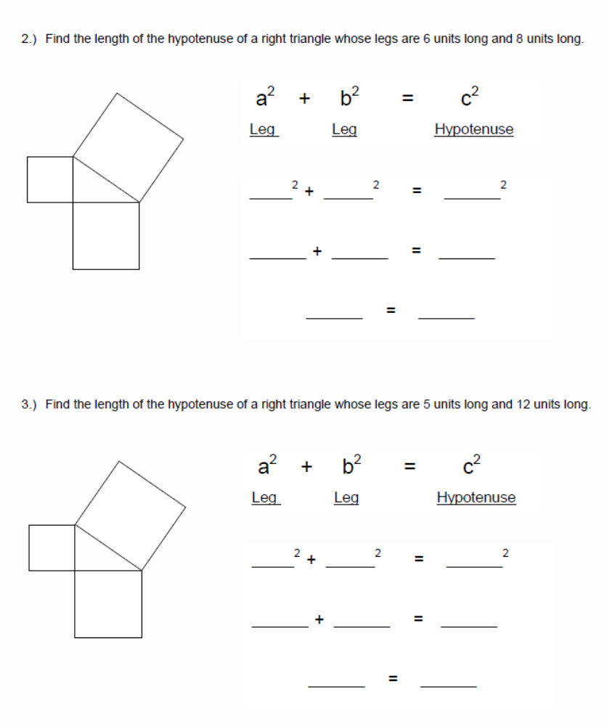

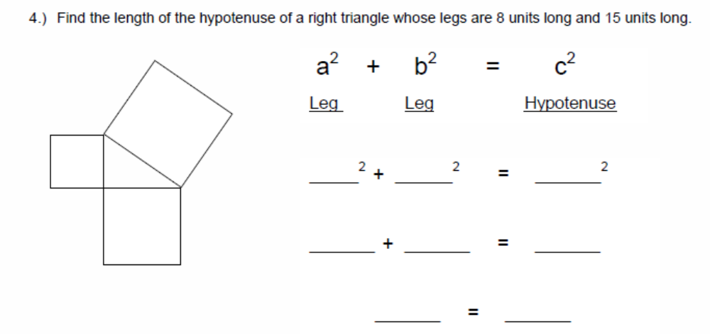

5) Find the length of the missing leg of a right triangle whose legs is 6 units long and hypotenuse is 18 units long.

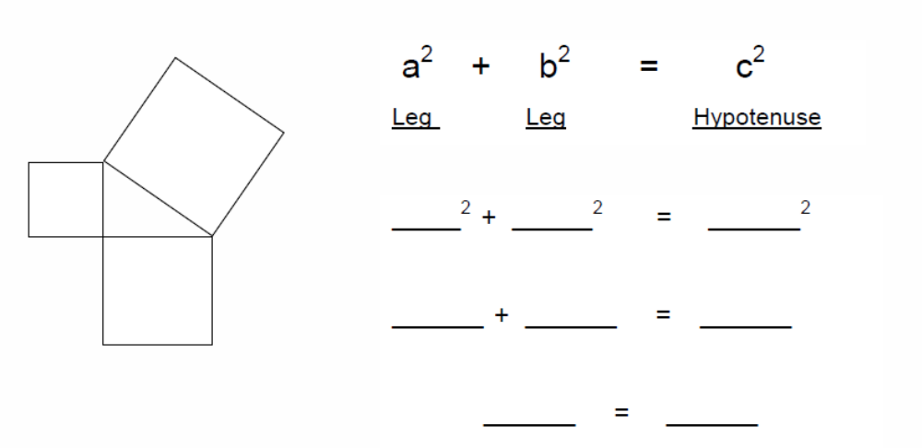

6) Find the length of the missing leg of a right triangle whose legs are 16 units long and 4 units long.

7) Find the length of the missing leg of a right triangle whose leg is 4 units long and hypotenuse is 12 units long.

8) Find the length of the missing leg of a right triangle whose leg is 9 units long and hypotenuse is 17units long.

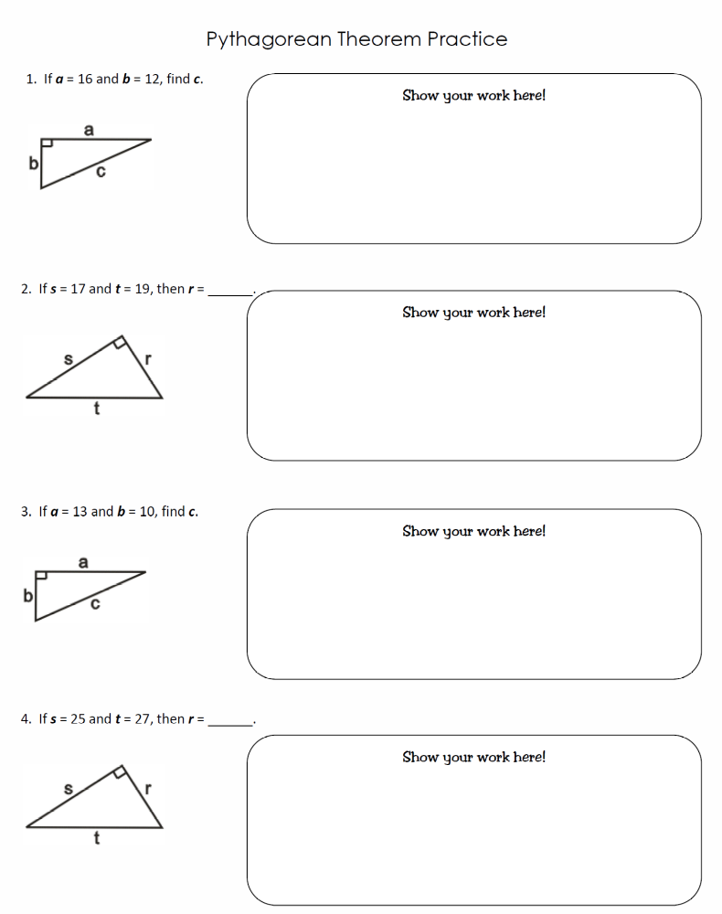
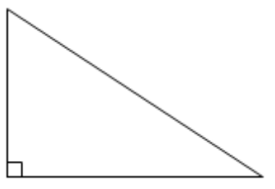
5
X
11

X

12

9

X

15

8

x

4

7

X

15

20

x

X

3

11

24

10

6

15

x

Name: ____________________________

Pythagorean Theorem Practice

In this section, find the length of the hypotenuse of each of the triangles. In the cases where the missing side is not a perfect square, find the EXACT answer.
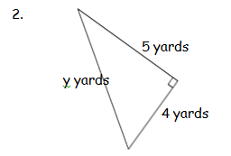
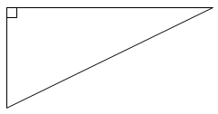
1. 8 m.

6 m. x m.

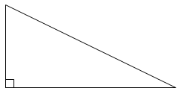
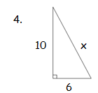
3. m

6
7

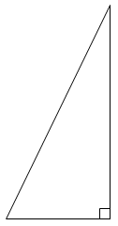
5. 6.

9 in
8
n in.
.
6 in.
n in.
5

7. 7 m. 8. 5 in.
5 in.
4 m.
x m.
x in.

X
9. 10.
4 11 meters
X meters
6

4 meters

11. 12.
y
9 cm 7 cm
1
8
X cm

Name: ____________________________

More Pythagorean Theorem Practice

Are these triangles right triangles?
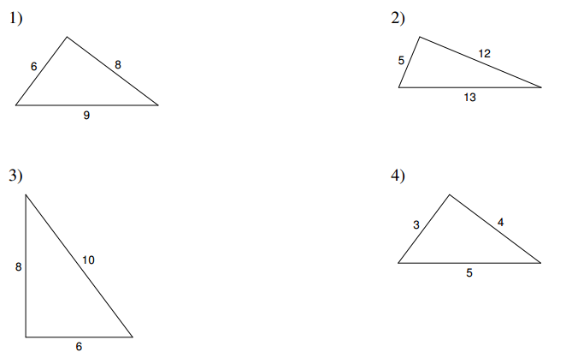

Find the EXACT lengths of the missing sides.
5. 6.
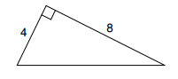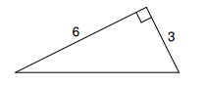

7. 8.
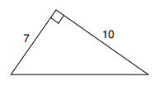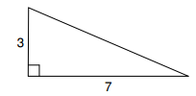

9. 10.
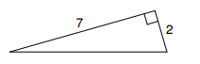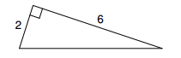

11. 12.
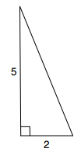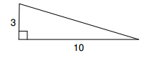

13. 14.
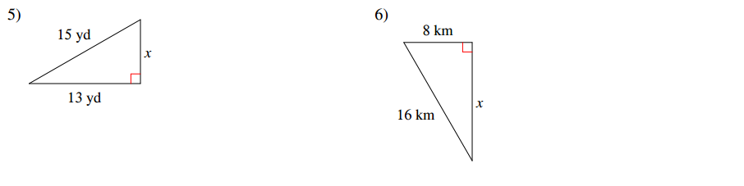

Exit Quiz!
Find the EXACT length of the missing side.

6 in.
2.
1. 8 m.
x in.
6 m.
x m.

6 in.

3. 4.
p

5
h meters
5 meters

12

10 meters

5.
2 cm
5 cm

x cm

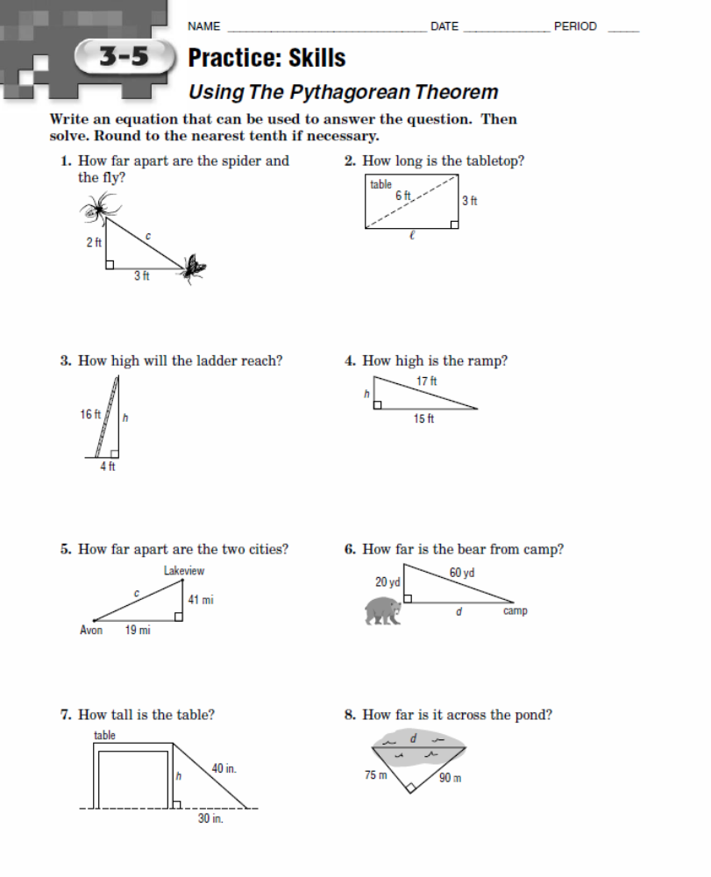

Pythagorean Problem

What is the perimeter of the triangle below?

5 cm

12 cm

What is the perimeter of the triangle below?

15 cm

12 cm

What is the perimeter of the triangle below?

6 cm

8 cm

What is the perimeter of the triangle below?

15 cm

8 cm

What is the perimeter of the triangle below after a scale factor of 2 is applied?

4 cm
3 cm

Name: ___________________
Classwork: Pythagorean Theorem

x | 1 | 2 | 3 | 4 | 5 | 6 | 7 | 8 | 9 | 10 | 11 | 12 | 13 | 14 | 15 | 16 | 17 | 18 | 19 | 20 | 21 | 22 | 23 | 24
x ² | 1 | 4 | 9 | 16 | 25 | 36 | 49 | 64 | 81 | 100 | 121 | 144 | 169 | 196 | 225 | 256 | 289 | 324 | 361 | 400 | 441 | 484 | 529 | 576

Label the sides of each triangle a, b, and c. Then, find the length of the missing leg. Use the table above to estimate the square roots. SHOW YOUR WORK.
x
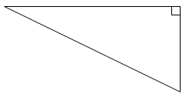
1. 8 m. 2.

10 m.
12
15
x

x

3. 4.
14
6
7
4
x

x
9
5. 6.
5
11
10 in.

x

7. 12 m. 8.
x

9 m.
x
9
9

9. 10.
x
x
9
3

4
6

11. Rafael and Dan are writing an equation to find the length of the third side of the triangle.

Rafael:
c² = 29² + 21²
Dan:
29² = a² + 21²
21 in.
29 in.

a.) Who is correct? Explain.

12. Find the missing side length and the perimeter of the triangle below.
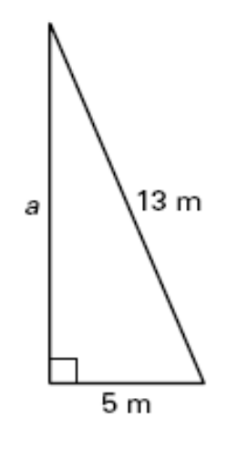

Side length: ____________ m Perimeter: ____________ m

Exit Quiz2!

1. x m. 2.
12 in.

7 m.
11 m.
15 in.
x in.

10 in.
3. 4.
6 in.
7 in.
10 in.
x in.

x in.
x in.

5. Find the missing side length and the perimeter of the triangle below.

10 m.

6 m.

Side length: ____________ m Perimeter: ____________ m

Name: _______________________________________
Homework: Pythagorean Theorem

1.) Write and solve an equation to find the unknown side length for each triangle.

15 ft
17 ft

- Find the length of the hypotenuse.
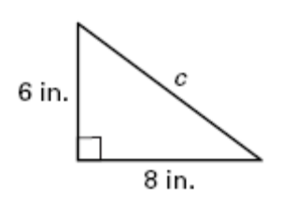

The length of the hypotenuse is __________ inches.

3.) The length of one leg of a right triangle is 12 meters and the other leg is 16 meters. What is the length of the hypotenuse? Hint: Draw a picture!

(a) 10 m (b) 20 m

(c) 16 m (d) 40 m

4.) Find the missing side length and the area of the triangle below.

Side length: ____________ m

5.) Find the missing side length and perimeter of the triangle on the right.
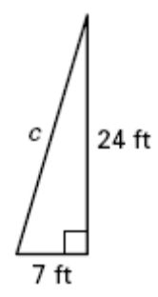

Determine if three segments with the given lengths form a right triangle. Write yes or no. Show your work.

- 1 ft., 60 ft., 61 ft. 7.) 8 cm., 9 cm., 12 cm.

Spiral Review:

8) Write 7.05 × 10⁶

10.) Use the input-output table to answer the following questions.
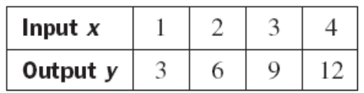
a.) Write a rule for the input-output table.

Rule __________________________________________________________________________
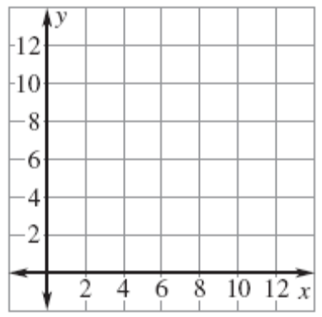
c.) Graph the values from the input-output table.

10.) You purchased 5 movie tickets, which cost a total of $34.75. How much did one movie ticket cost?

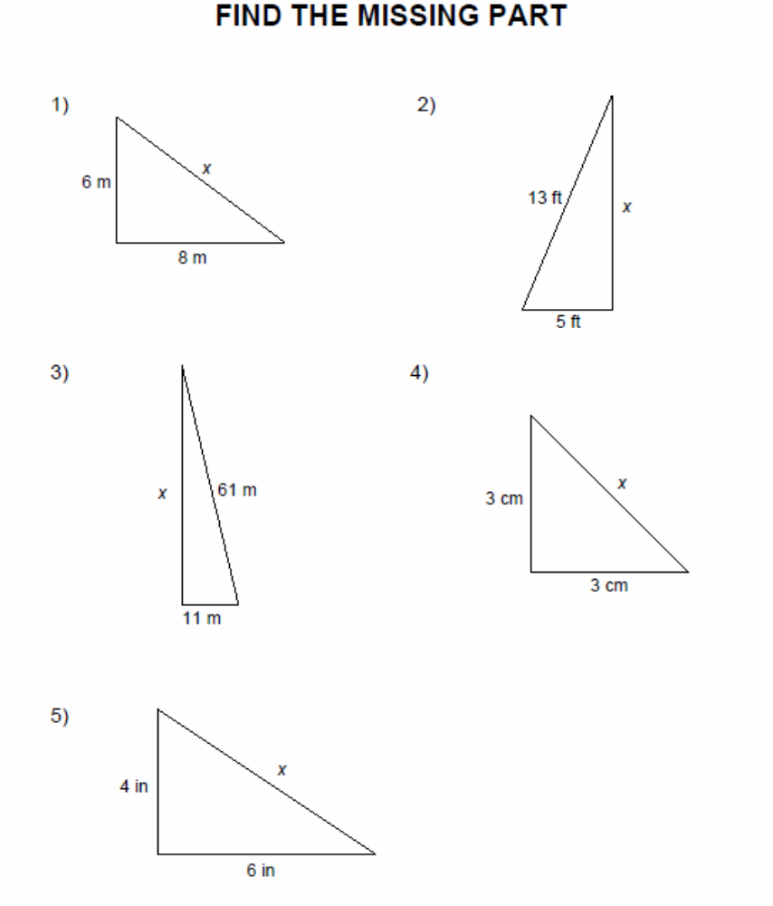

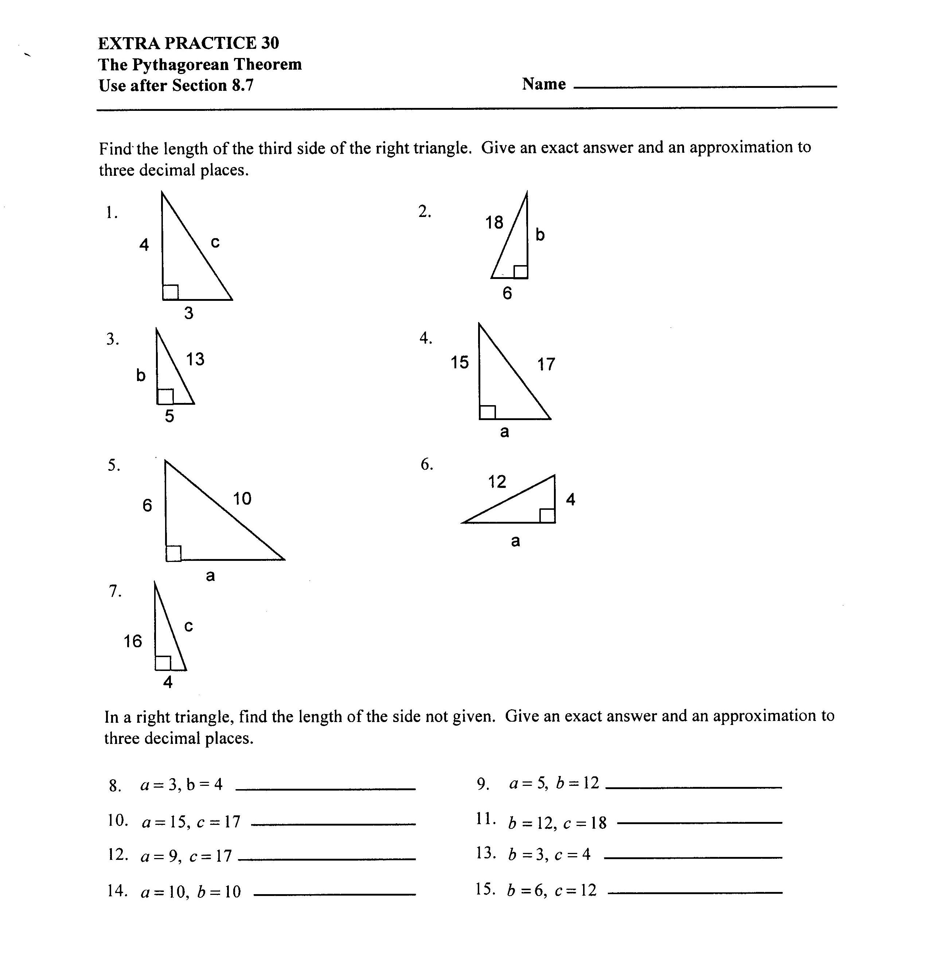

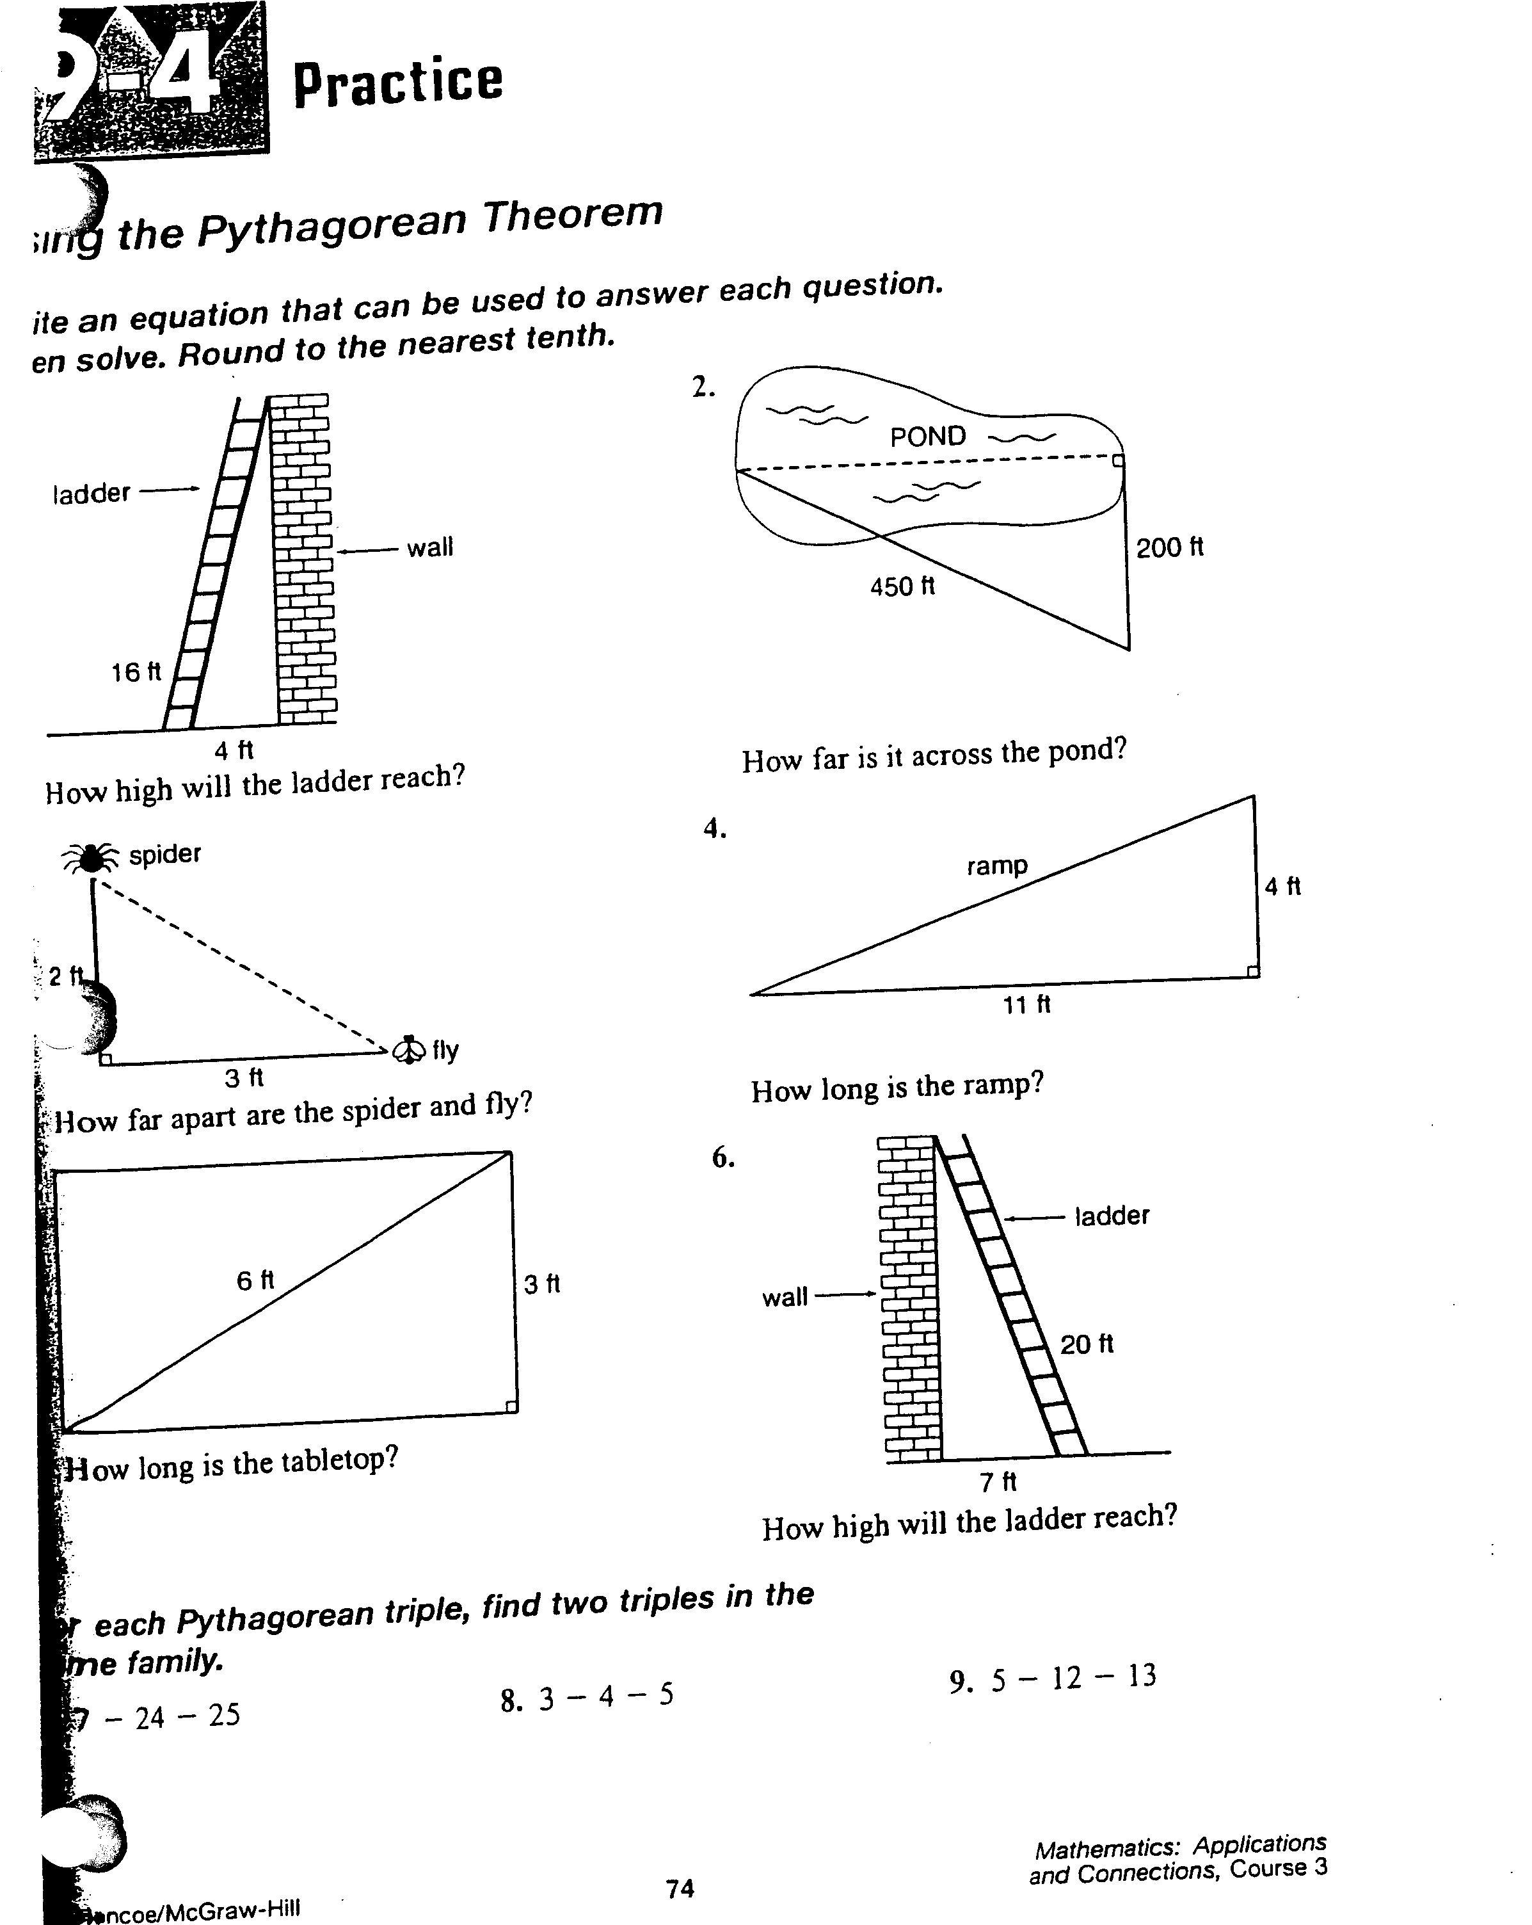

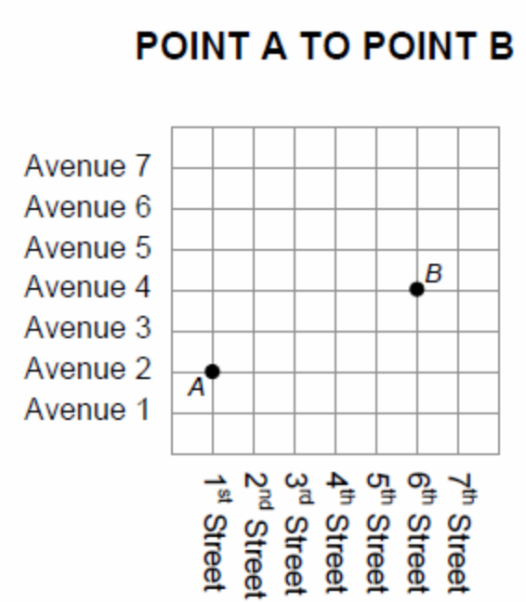

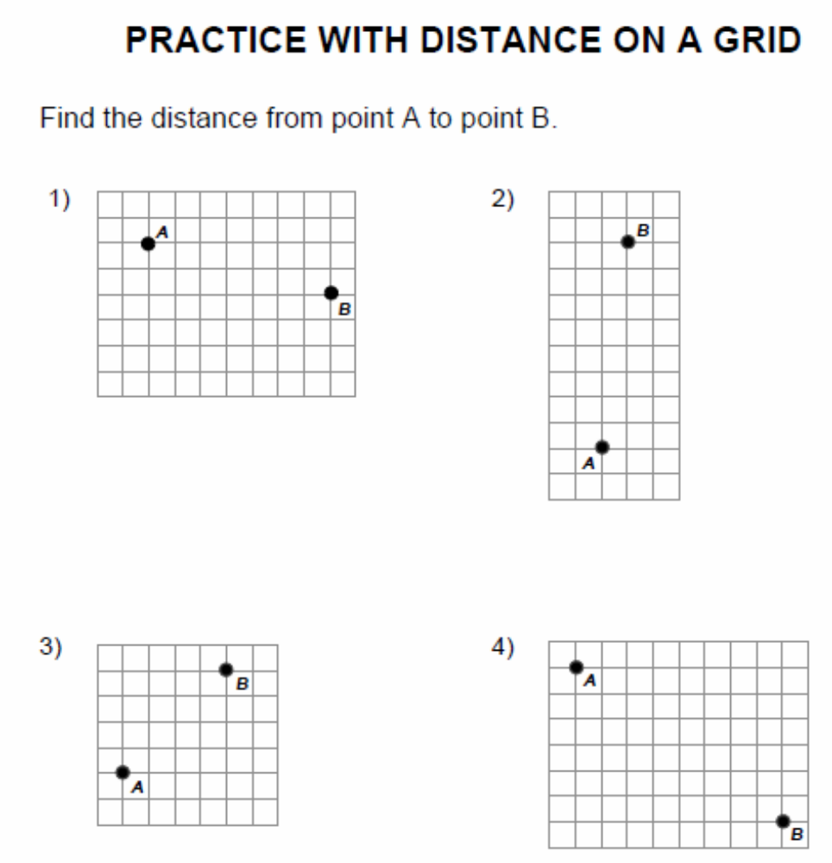

EXAMPLE #1: Graphing Triangles to find Missing Lengths

a.) Graph the following points on the coordinate plane below: W: (–4, 6), D: (8, 1)
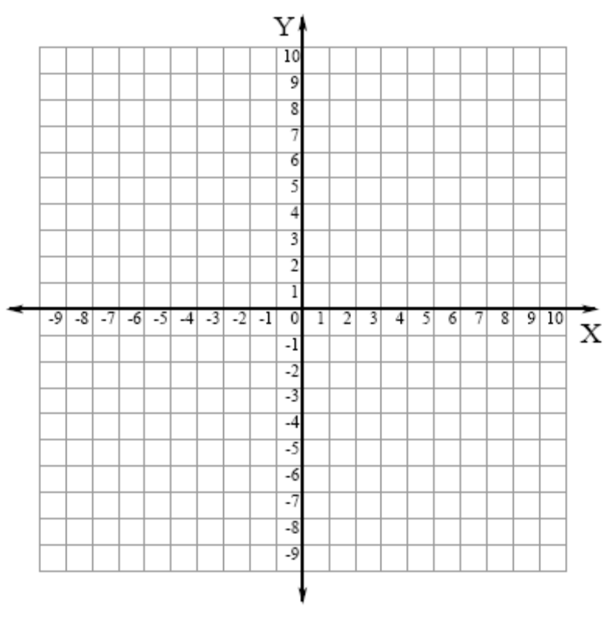

b.) Draw a third point, P, so that you have created right triangle WDP.

Coordinates of point P: _________________

c.) Find and label (on the graph) the lengths of and .

: _____________ units : ______________ units

d.) Using the Pythagorean Theorem, find the length of .

EXAMPLE #2: Graphing Triangles to find Missing Lengths
Graph the following points on the coordinate plane below: M: (–2, 3), I: (1, –1)

b.) Draw a third point, A, so that you have created right triangle MIA.

Coordinates of point A: _________________

c.) Find and label (on the graph) the lengths of and .

: _____________ units : ______________ units

d.) Using the Pythagorean Theorem, find the length of .

= _______________ units

Example 3 – The Pythagorean Theorem in the Coordinate Plane

The vertices of a figure in the coordinate plane contain the points A(-5, 6), B(2, 6), and C(-5, 2). Find the lengths of each side of the figure to the nearest tenth of a unit.
y

x

Example 4 – The Pythagorean Theorem in the Coordinate Plane
The vertices of a figure in the coordinate plane contain the points A(-1, 5),
B(-7, 5), and C(-7, -4). Find the lengths of each side of the figure to the nearest
tenth of a unit. y

x

Name ________________________________________

Pythagorean Theorem on the Coordinate Plane

Graph and label the following points on the coordinate plane. Connect the points. Make sure to answer the question.

- P(1,7) Q(9,7) R(9,1) What is the length of side PR?

2. A(-5,4) B(-9,4) C(-9,-3) Find the perimeter of figure ABC.

- X(3,-2) Y(9,-2) Z(9,6) Find the length of side XZ.

4. A(-2,-3) B(-2,7) C(8,-3) Find the perimeter of figure ABC.

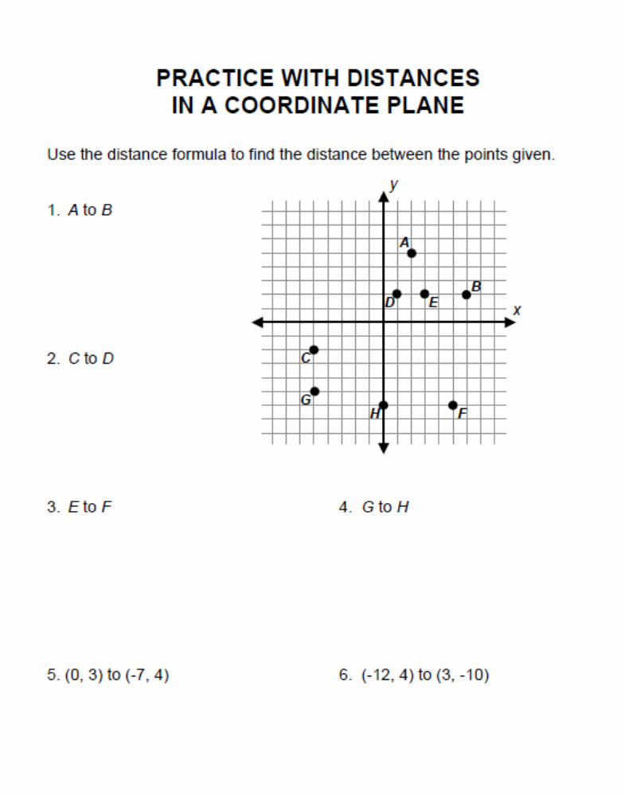

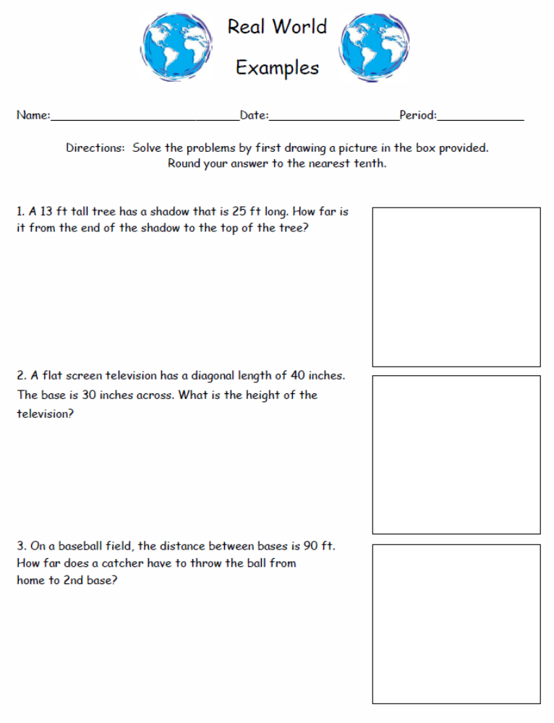

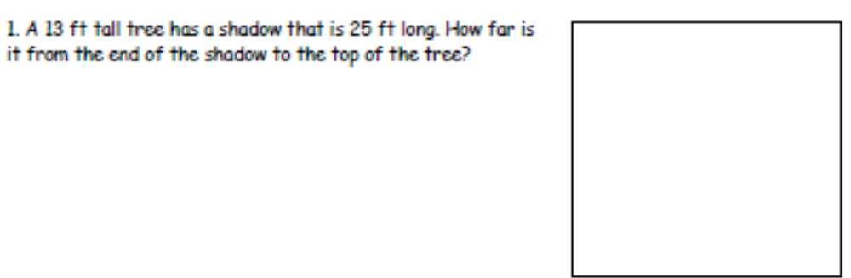
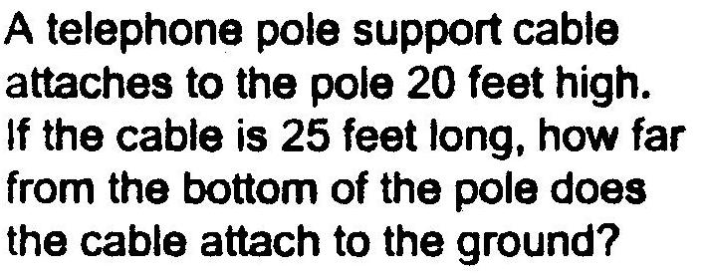

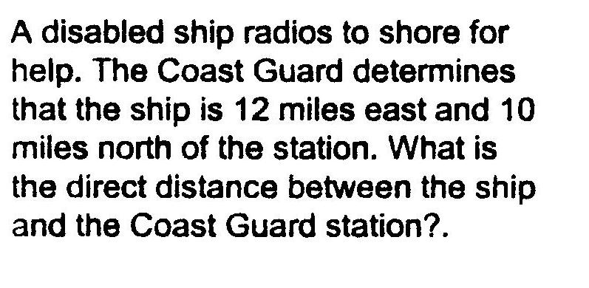
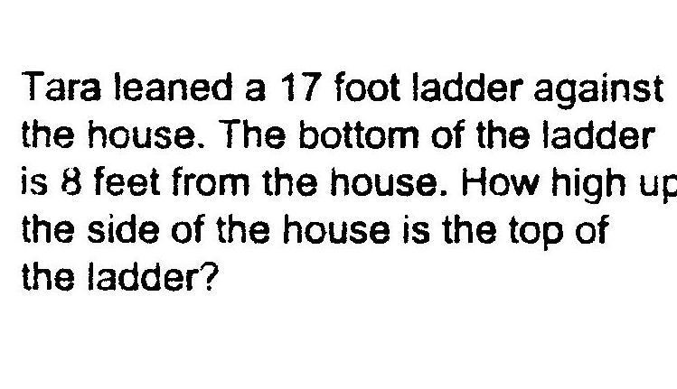
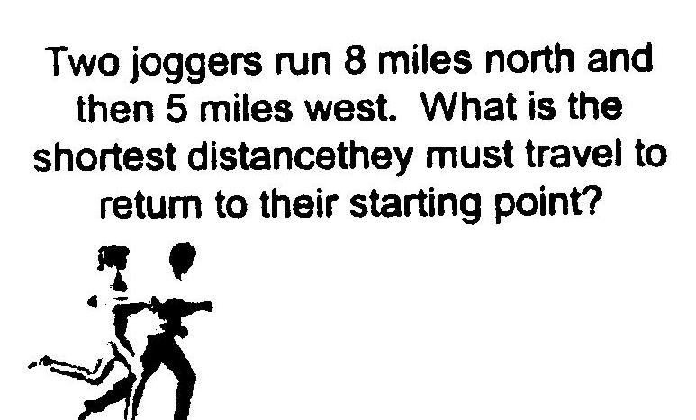

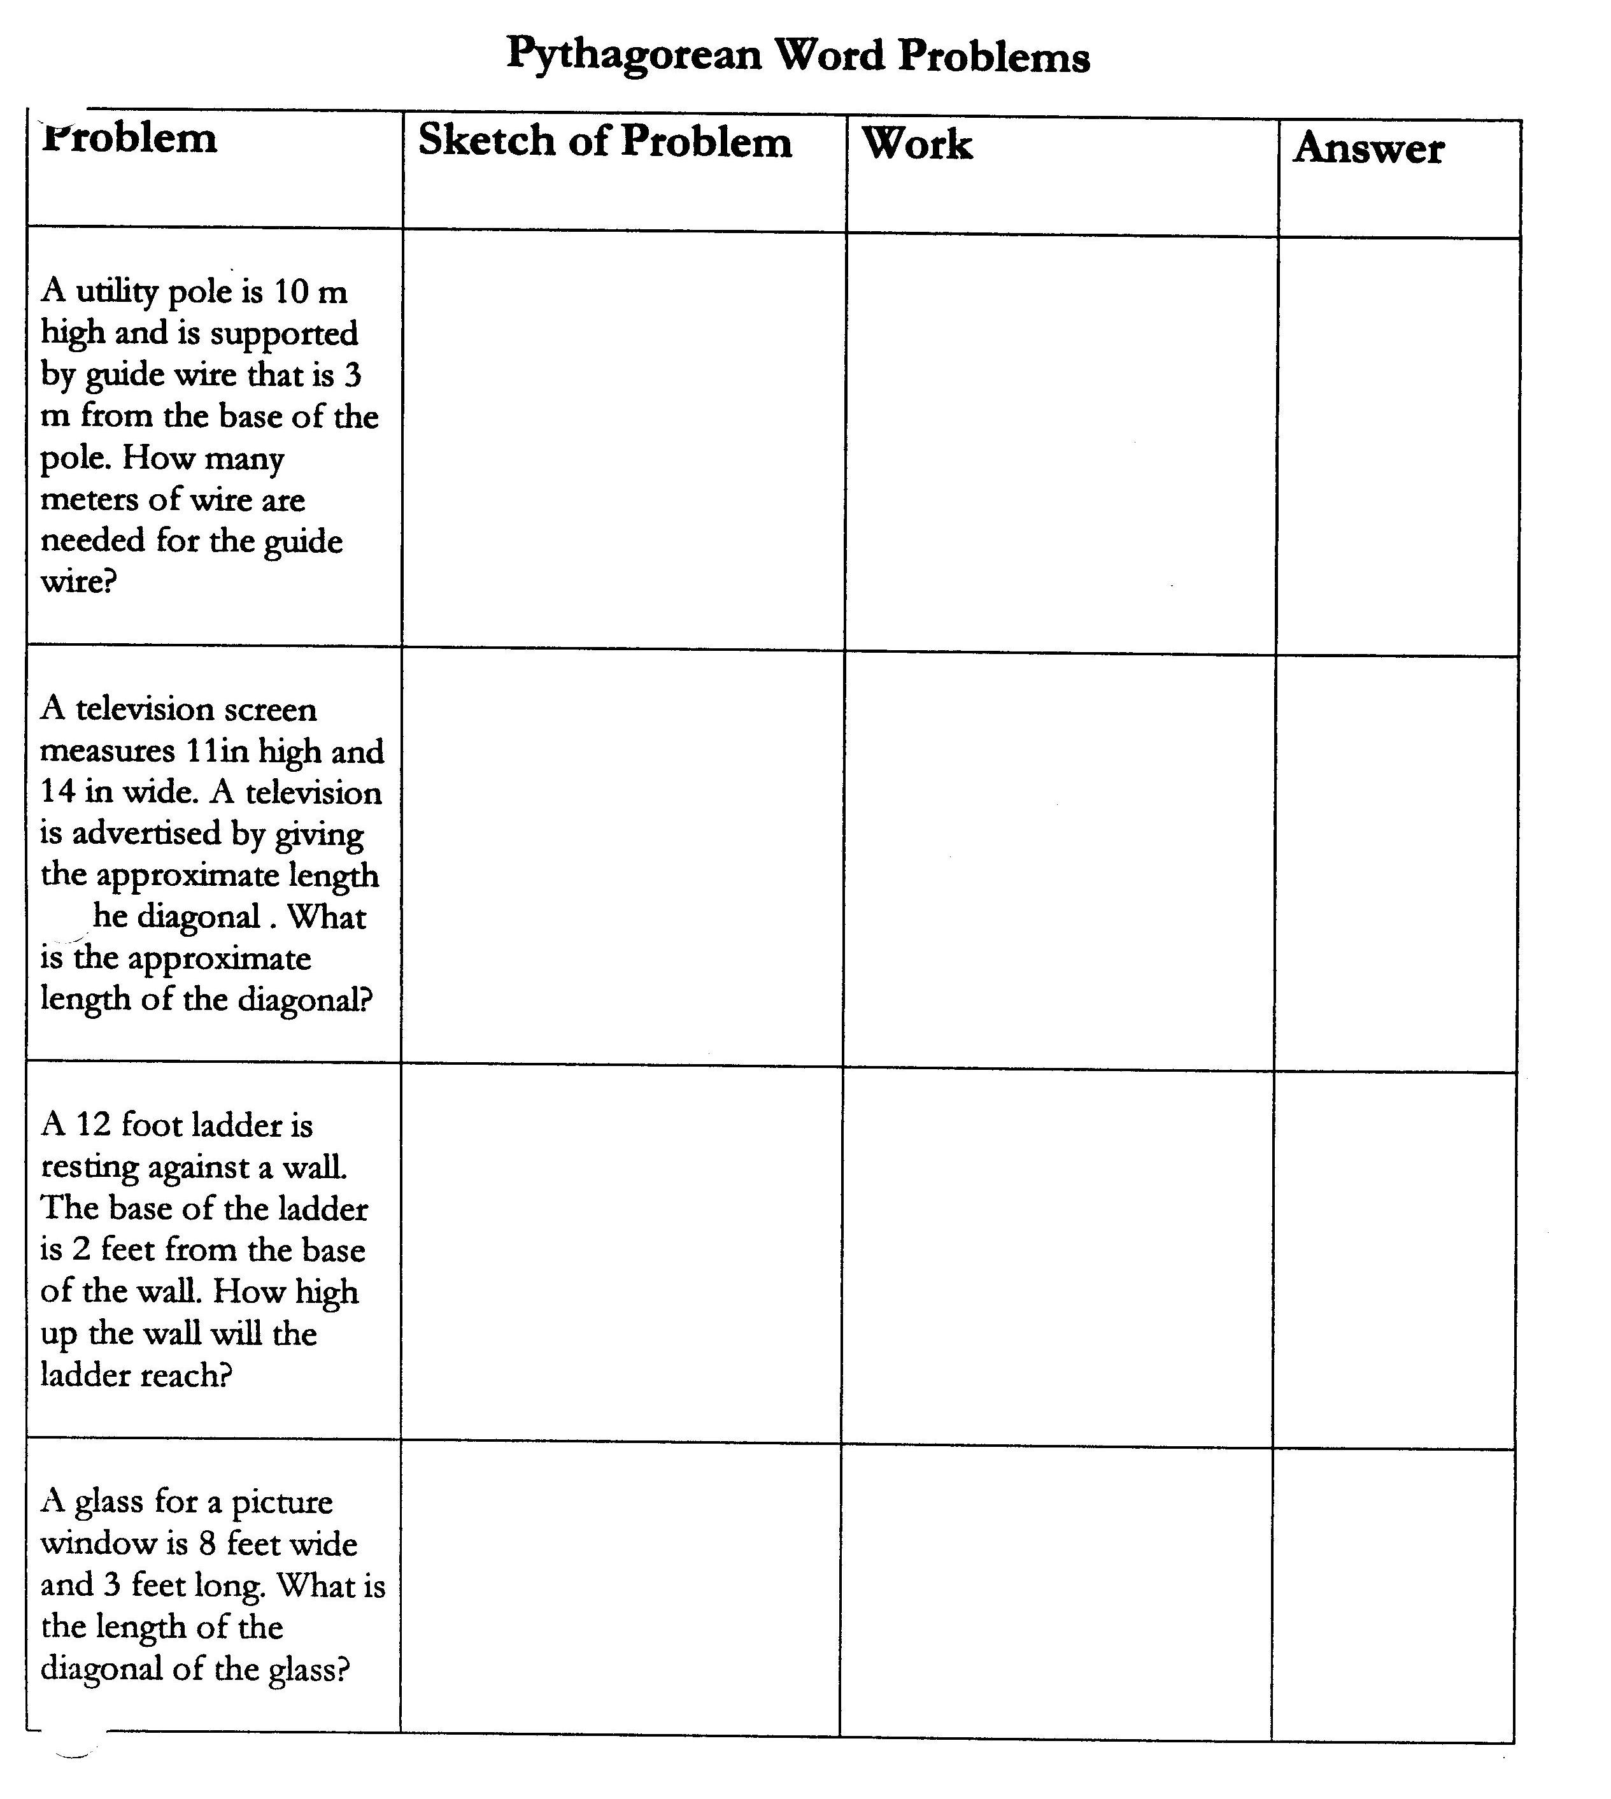

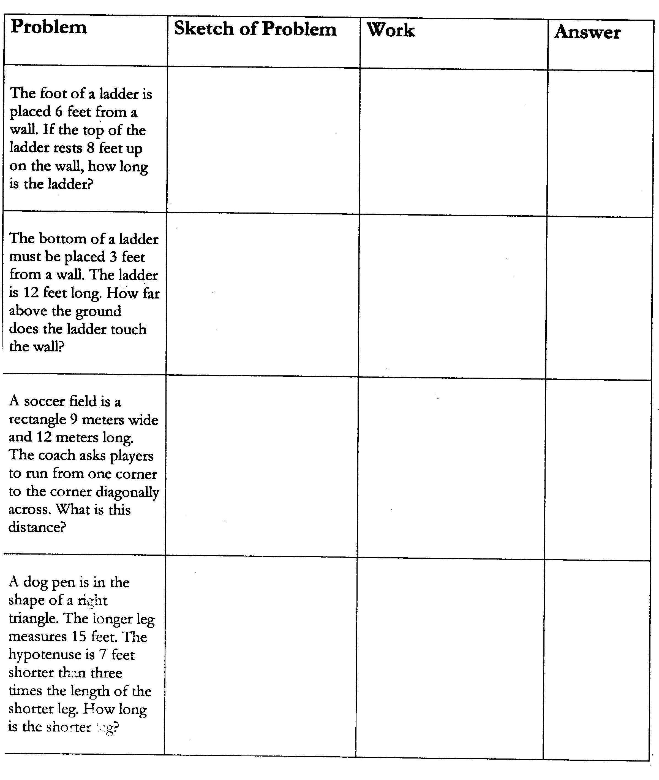
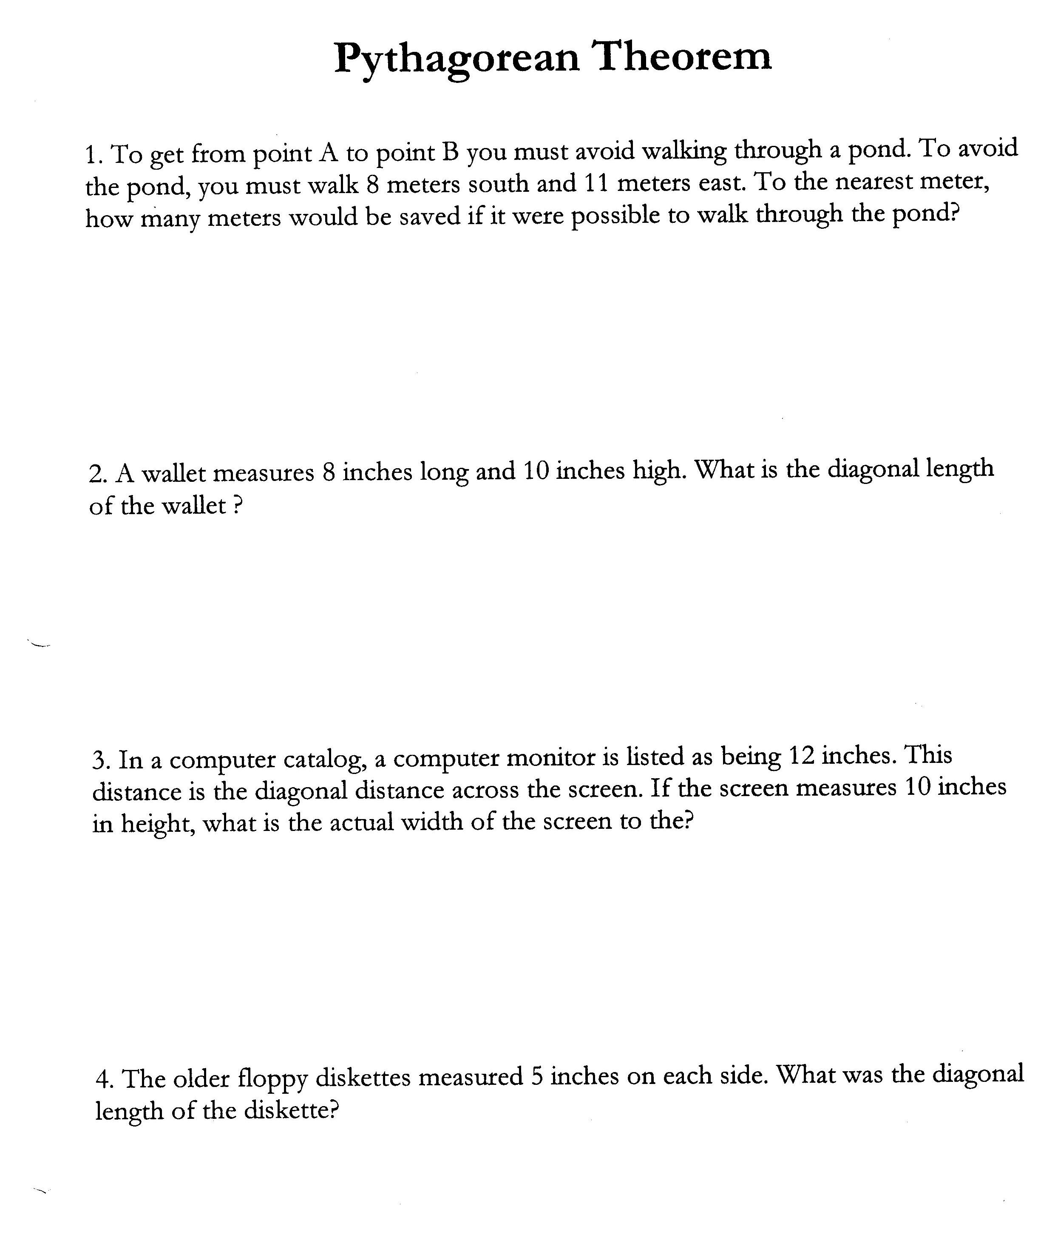

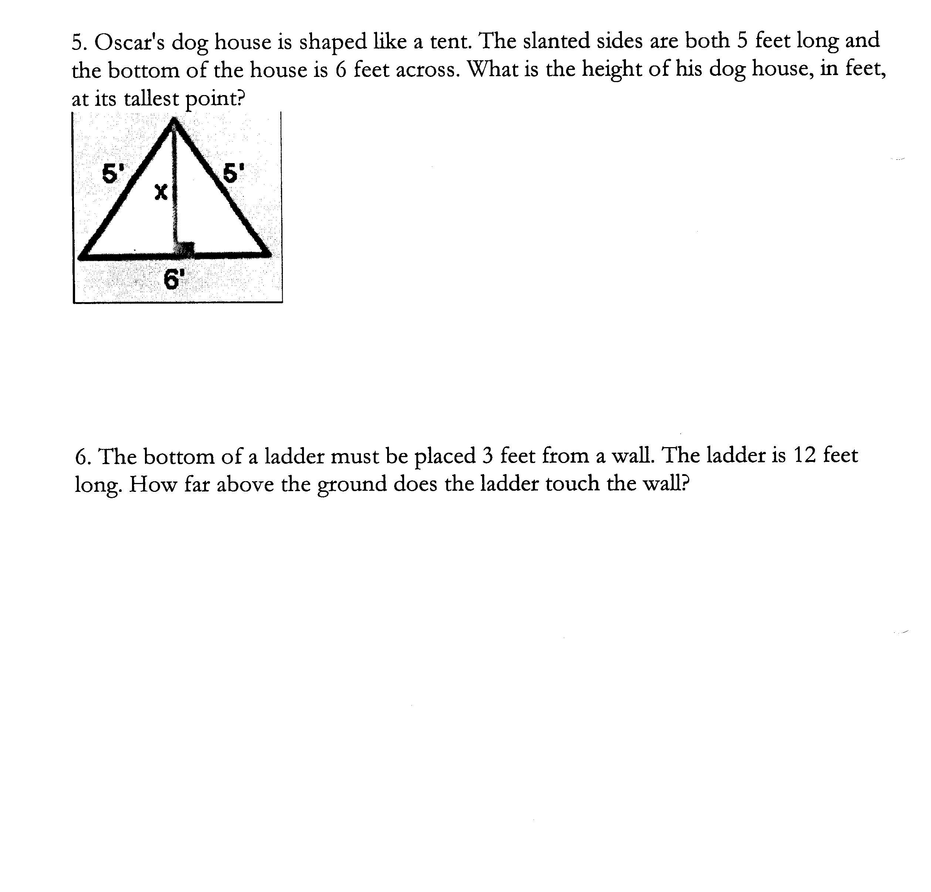
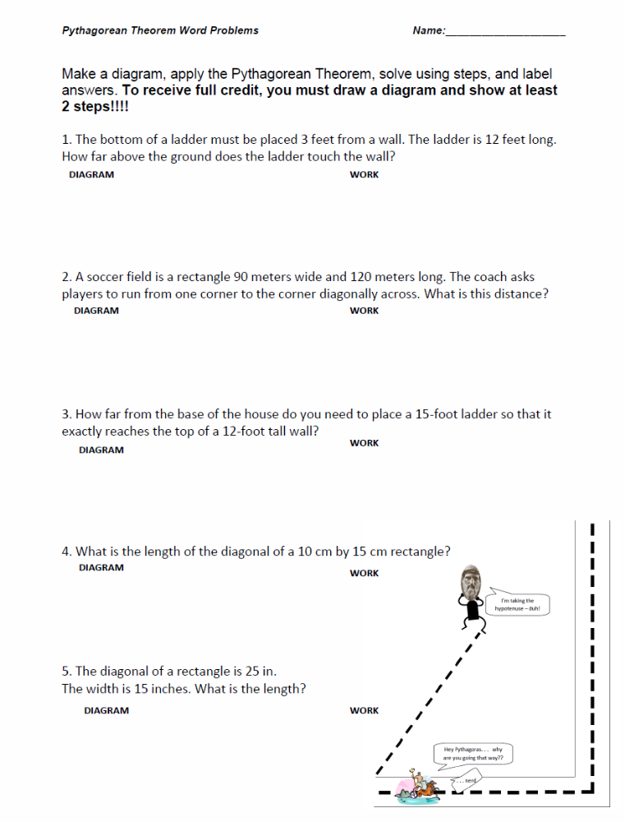

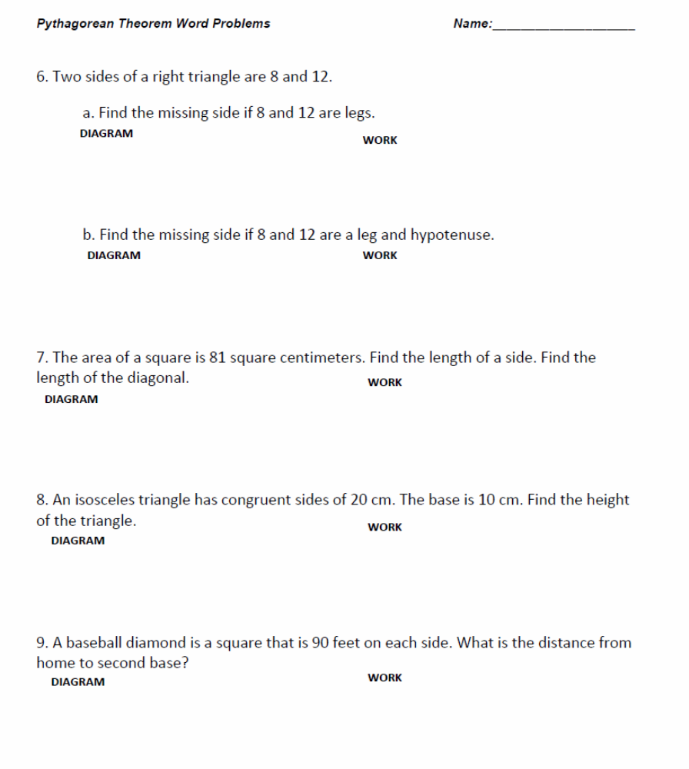

NAME: ______________________________

1)

3 m

4 m

Find the perimeter of the triangle above.

16 cm

20 cm
Find the missing side length of the triangle above

3) Mr. Thompson created a mosaic tile in the shape of a
square to place in his kitchen.


9 in

9 in

Which is the closest to the length of the diagonal of the tile?

a. 10 in
b. 13 in
c. 15 in
d. 17 in

4.)
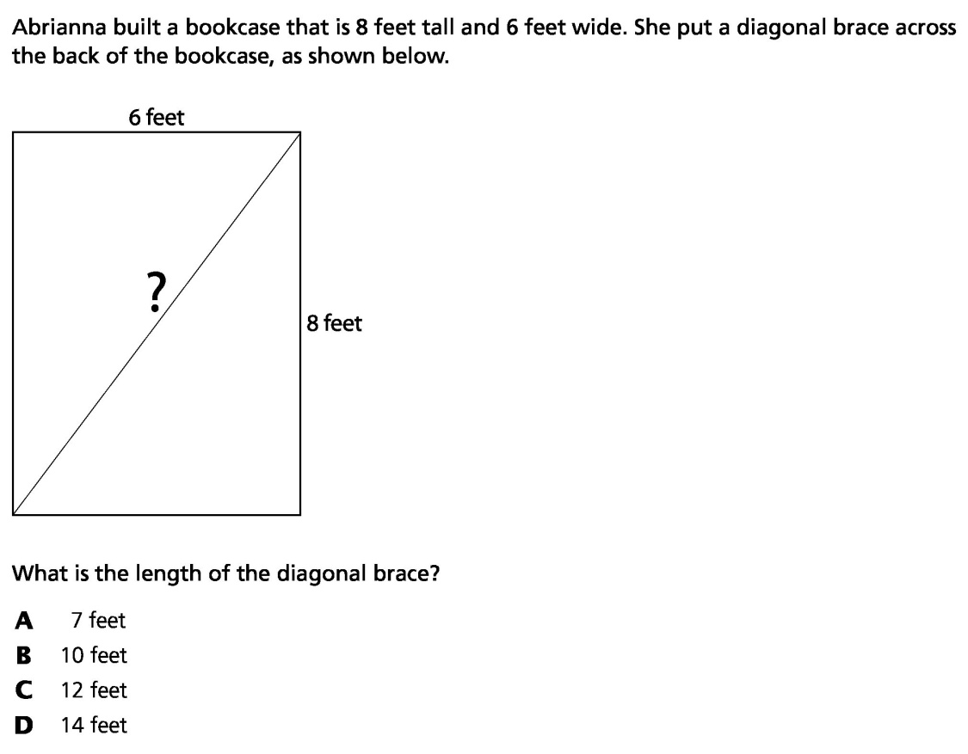

5)
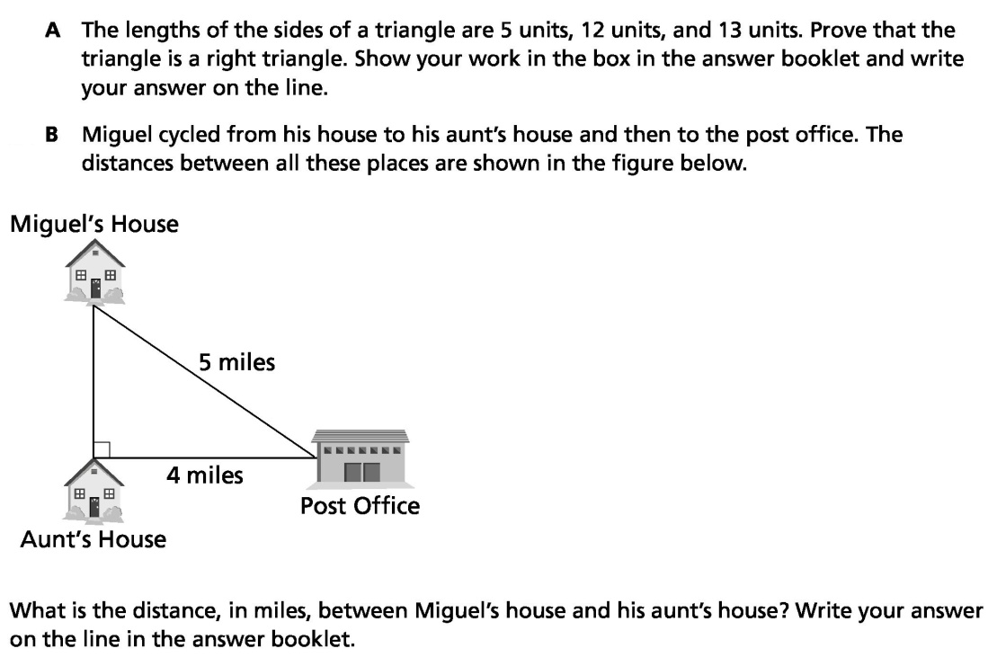

Mixed Practice with Pythagorean Theorem


1. A painter places an 11-ft ladder against a house. The base of the ladder is 3 feet from the house. How high on the house does the ladder reach?

2. Darla hikes due north for 6km. She then turns due east and hikes 3km. What is the direct distance between her starting point and stopping point, rounded to the nearest tenth of a kilometer?

3. A wire from the top of a telephone pole is anchored to the ground 12 feet from the base of the pole. The pole is 16 feet tall. How long is the wire?

4. A rectangular park measures 30 yards by 40 yards. A sidewalk runs diagonally from one corner of the park to the opposite corner. Find the length of the sidewalk.

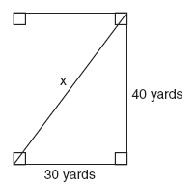
5)Tanya runs diagonally across a rectangular field that has a length of 40 yards and a width of 30 yards, as shown in the diagram.

What is the length of the diagonal, in yards, that Tanya runs?

6) Jim works for a landscaping company. He must plant and stake a tree. The stake is 2 feet from the base of the tree. The stake is attached to a wire that connects to the tree trunk at a height of 5 feet. How long must each wire be?

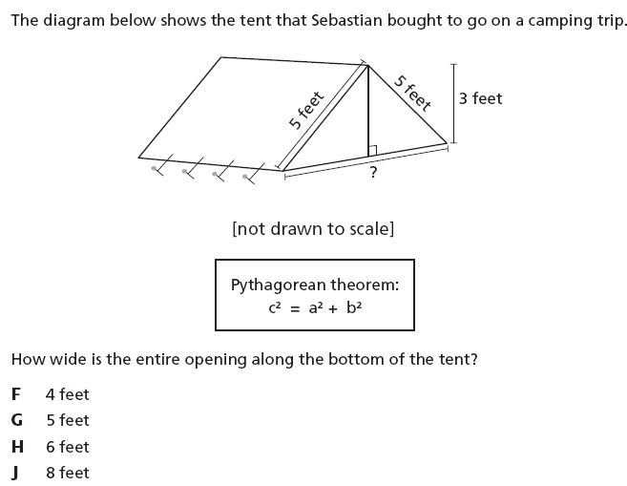
7)

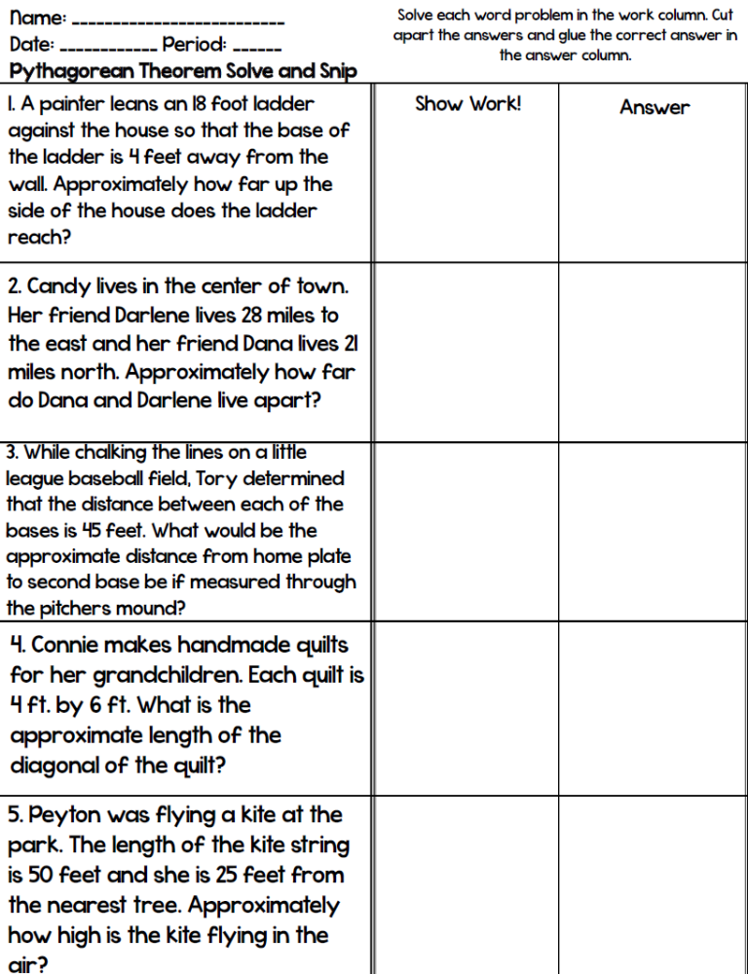

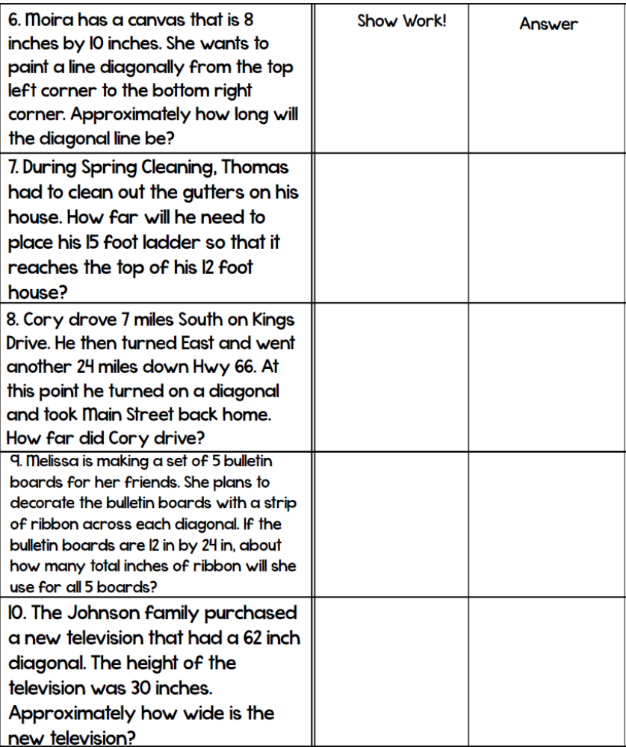

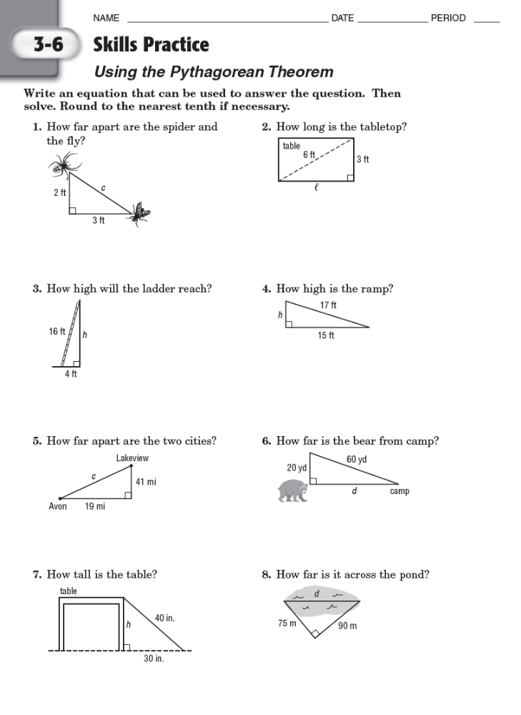

ACTIVITIES

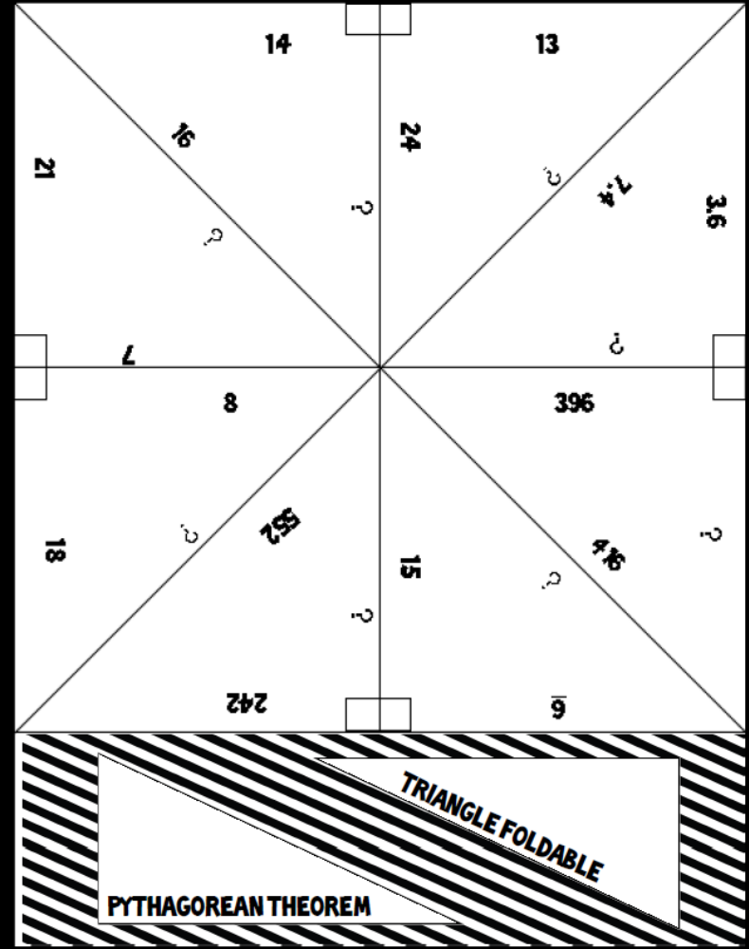
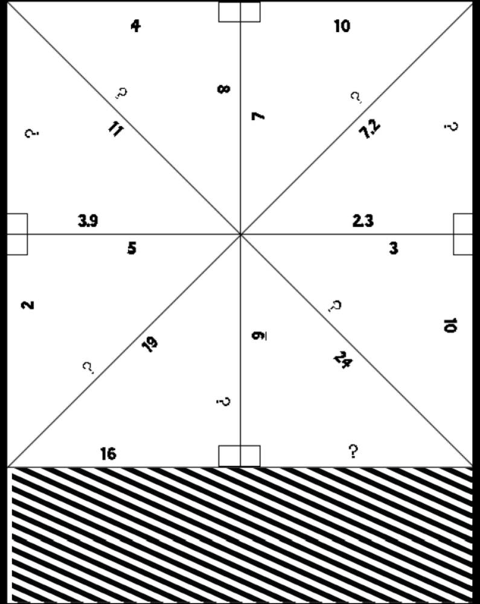
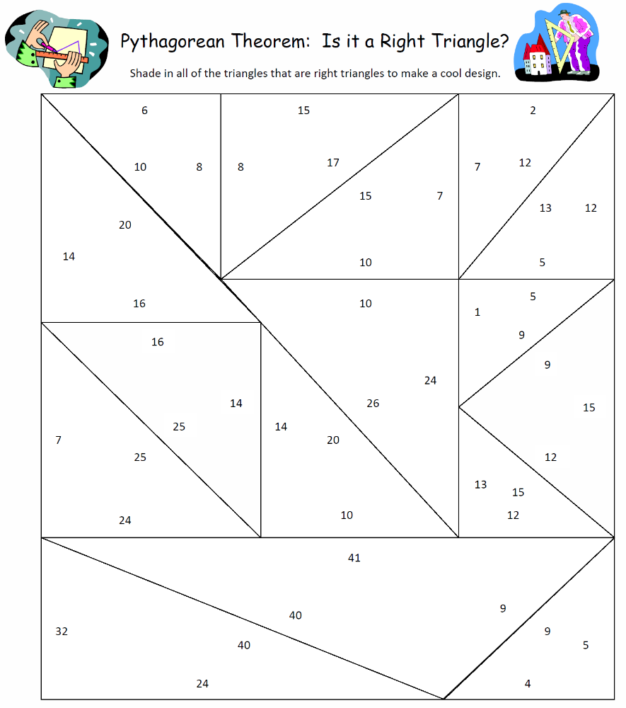

________________________________

________________________________

________________________________

1) The diagram below shows the dimensions of a rectangular field.
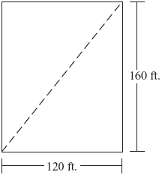
What is the length of a diagonal of the field?
 | A. | 12 ft.
 | B. | 20 ft.
 | C. | 39.4 ft.
 | D. | 52 ft.

2)Find the length of BD in the rectangle below.

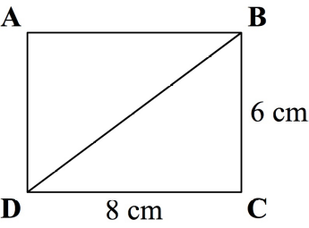

A) 10 cm
B) 14 cm
C) 48 cm
D) 100 cm

3) Which of the following triangles are congruent?

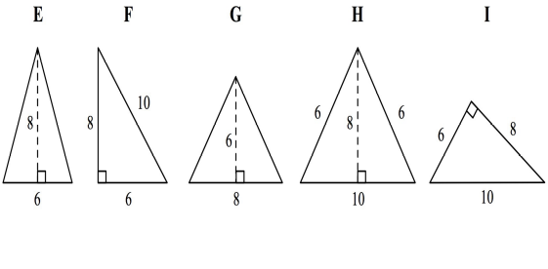

A) Triangle E and Triangle F
B) Triangle E and Triangle G
C) Triangle F and Triangle I
D) Triangle H and Triangle I

4) Find the distance between Point A and Point B on the coordinate plane below.
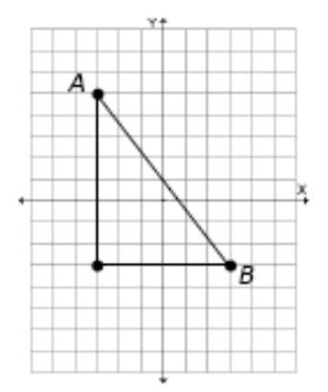

A) 6
B) 8
C) 10
D) 12

Applying the Pythagorean Theorem
1

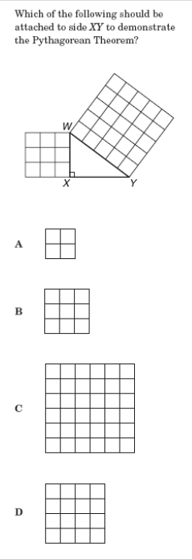

Applying the Pythagorean Theorem
1

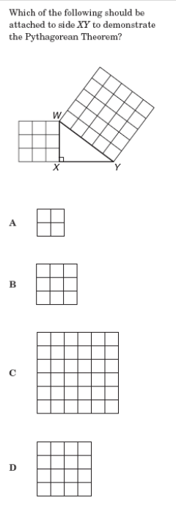

Applying the Pythagorean Theorem
3

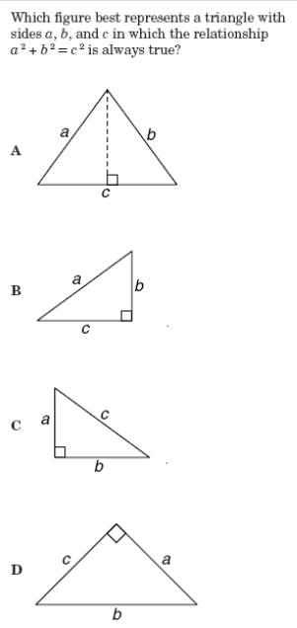

Applying the Pythagorean Theorem
4

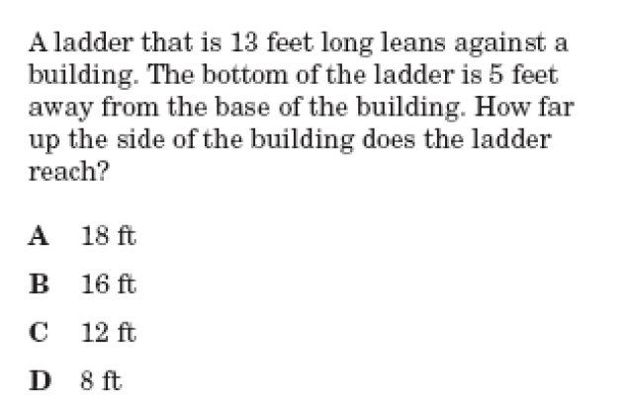

Applying the Pythagorean Theorem
5

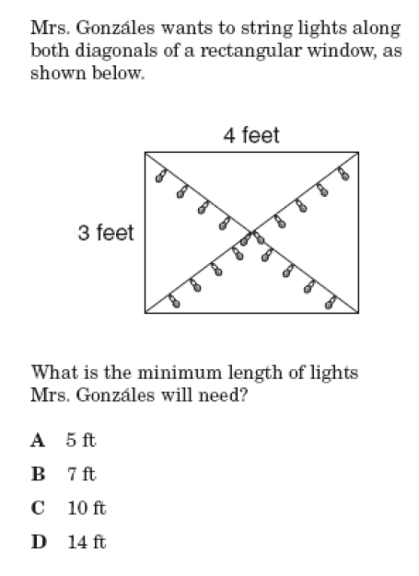

Applying the Pythagorean Theorem
6

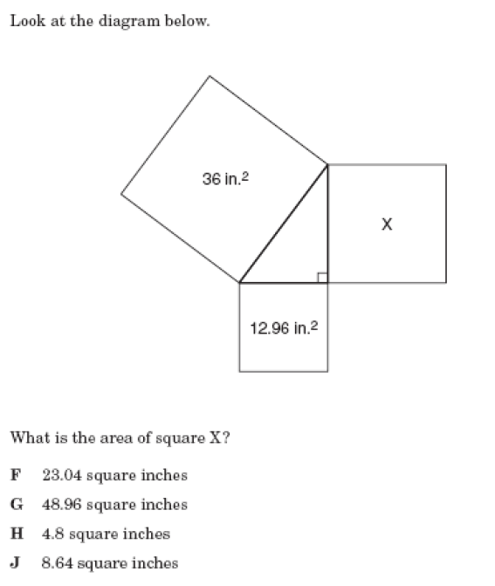

Applying the Pythagorean Theorem
7

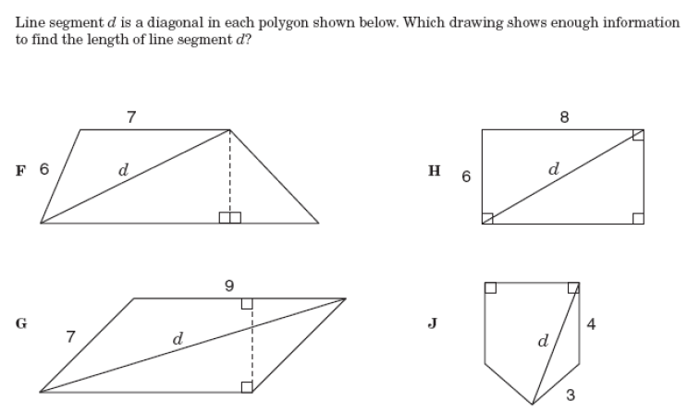

Applying the Pythagorean Theorem
8

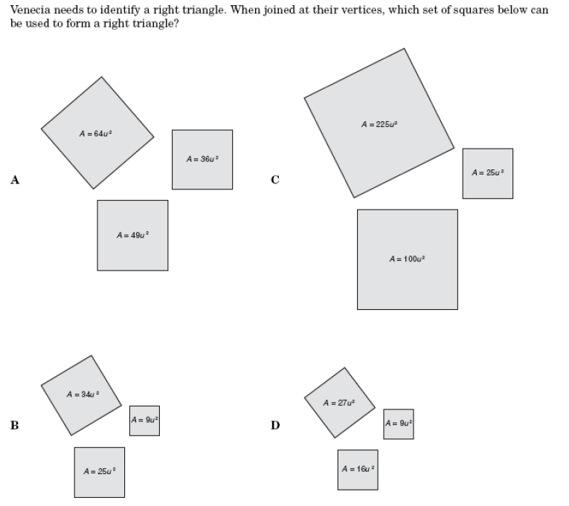

Applying the Pythagorean Theorem
9

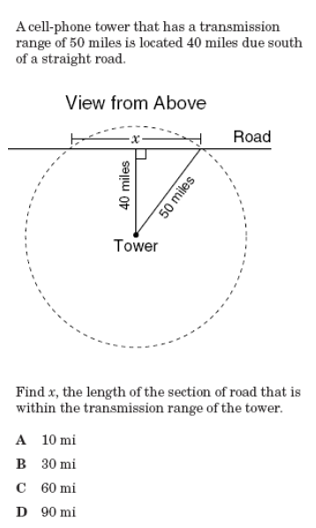

Applying the Pythagorean Theorem
10

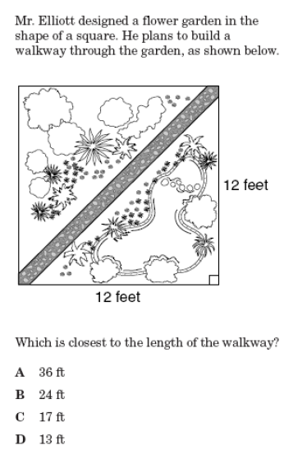


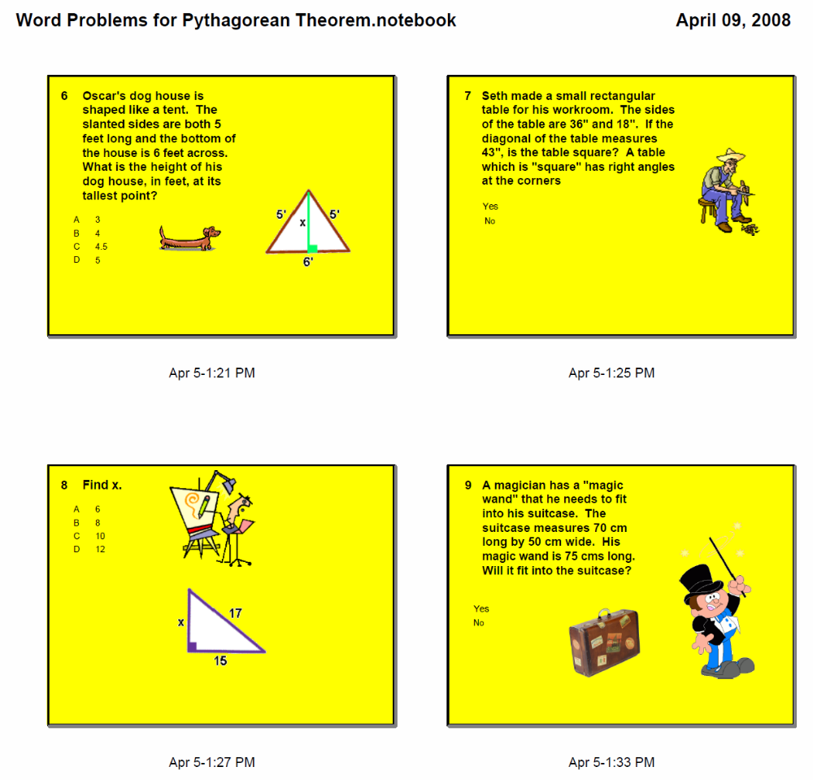

Independent Practice
Draw a model for each question. Be careful with which side you are finding!
1. The diagonal distance covered by a flight of stairs is 15 ft. If the stairs cover 10 ft. horizontally, how tall are they?

2. The supermarket is 9 miles east of a house. Target is 10 miles north of the supermarket. How far is it from the house to Target?

3. The diagonal of a TV screen is 25 inches. If the length of the screen is 20 inches, what is the height of the TV screen?

4. A jogger ran 3 miles west and 7 miles north. How far was he from his starting point?

5. A projector screen at a movie theater is a rectangle with width 8 feet and height 6 feet. What is the length of the diagonal of the projector screen?

6. A ladder was left leaning up against a wall. If bottom of the ladder is touching the ground 4 feet out from the wall and the top of the ladder is touching 8 feet up on the wall, how long is the ladder?

7. A gymnastics tumbling mat is a square whose sides are each 10 feet. What is the approximate length of the diagonal from one corner of the mat to the other?

8. A jogger runs 10 miles west and the 3 miles north. If she wanted to run back traveling directly south east, how far would she have to run back?

9. Ryan walked 2 miles North and 5 miles East. How far away is he from his starting point?

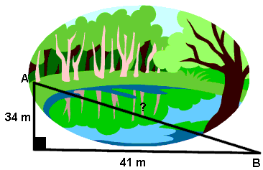
10. To get from point A to point B you must avoid walking through a pond. To avoid the pond, you must walk 34 meters south and 41 meters east. To the nearest meter, how many meters would be saved if it were possible to walk through the pond?

- To the nearest meter, find the distance across the pond.



