Algebra

Unit 7

Liner Equations Part 1
( Rate of Change, Slope, Writing Equations of Lines)

Name: ____________________

Teacher: _______________

Period: ________

Rate of Change Notes

Change in 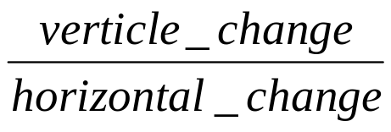
or Change in 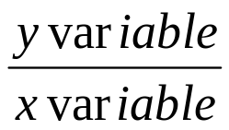

Find the rate of change for the situation:

Cost of Buying sandwiches

Rate of change=
No. of sandwiches | Cost
0 | 0
1 | $3
2 | $6
3 | $9
4 | $12
5 | $15
n

Rate of change= 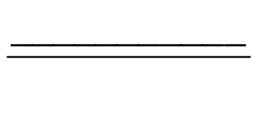

Rate of change=
Cost of Buying Pizzas
Rate of change=
No. of pizzas | Cost
1 | $6
2 | $12
2 | $18
3 | $24
4 | $30
n

Rate of change=

Cost of Buying CD’s

Rate of change=
No. of pizzas | Cost
3 | $39
4 | $52
5 | $65
6 | $78
7 | $91
n

Rate of change=

Miles traveled per gallon
Rate of change=
Gallons in tank | Miles traveled
11 | 134
12 | 144
13 | 156
14 | 168
15 | 180
n

Rate of change=

Rate of Change

Change in 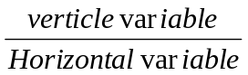 or Change in 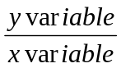

Situation: The table shows the high temperatures, H, in a city during the year as a function of the number of days, m, Month of the year. Graph the function. What is the rate of change?

Month | temperature
1 ( Jan) | 37
2 ( Feb.) | 45
3 ( March) | 53
4 ( April) | 61
5 ( May) | 69
6 ( June) | 77

- What is the x variable?

- What is the y Variable?

- What is the rate of change?

- What does the rate of change mean?

- What Equation matches the situation?

Rate of Change

Change in or Change in

Situation: The following table shows the amount of money spent as a function of the number of games played. What is the rate of change?

No. of games played | Money spent
2 | $4
4 | $8
12 | $24
24 | $48
32 | $64
n

1. What is the x variable?

- What is the y Variable?

- What is the rate of change?

- What does the rate of change mean?

- What Equation matches the situation?

Rate of Change

Change in or Change in

Situation:
The table shows the Cost of CD’s , C as a function of the number of CD’s N. Graph the function. What is the rate of change?
Number of CD’s | Cost
2 | $26
3 | $39
5 | $65
6 | $78
8 | $104

1. What is the x variable?

- What is the y Variable?

- What is the rate of change?

- What does the rate of change mean?

- What Equation matches the situation?

Rate of Change Practice

- Jason’s wants to buy a new bicycle. The bike cost $150. He already has$50 in the bank and decided to deposit $10 each week.

  - Complete the table and graph for the above situation.
week | Amount in bank
0
1
2
3
4
5
n

  - Identify the rate of change. What does it represent in this situation?

  - Write a rule for this situation.

  - How much money will Jason have in the bank after 6 months?

  - How many weeks will it take Jason to save for the bike? Explain.

- Phillip decided to compete in the Houston MS 150, a charity bike ride from Houston to Austin. The following chart shows How far he traveled after each hour.

  - Complete the table and graph for the above situation.
Hours | Distance biked
0 | 0
1 | 12 miles
2 | 24 miles
3 | 36 miles
4 | 48 miles
5 | 60 miles
n

  - Identify the rate of change. What does it represent in this situation?

  - Write a rule for this situation.

  - How far will Phillip have traveled after 6 hours?

e. How many hours will it take Phillip to ride 150 miles? Explain

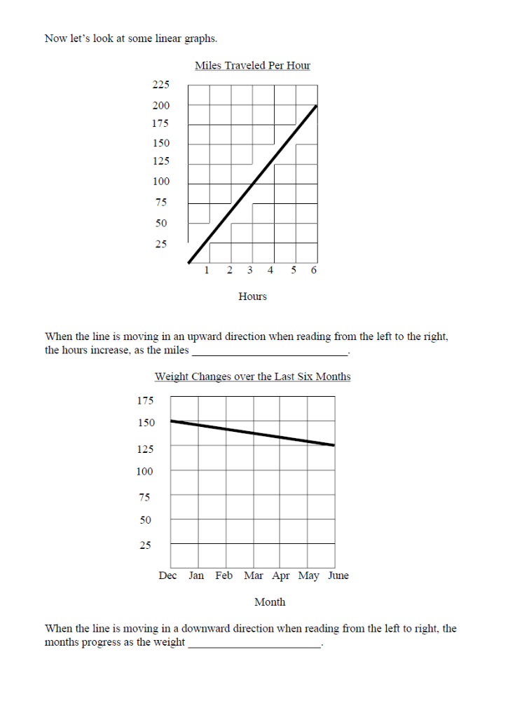

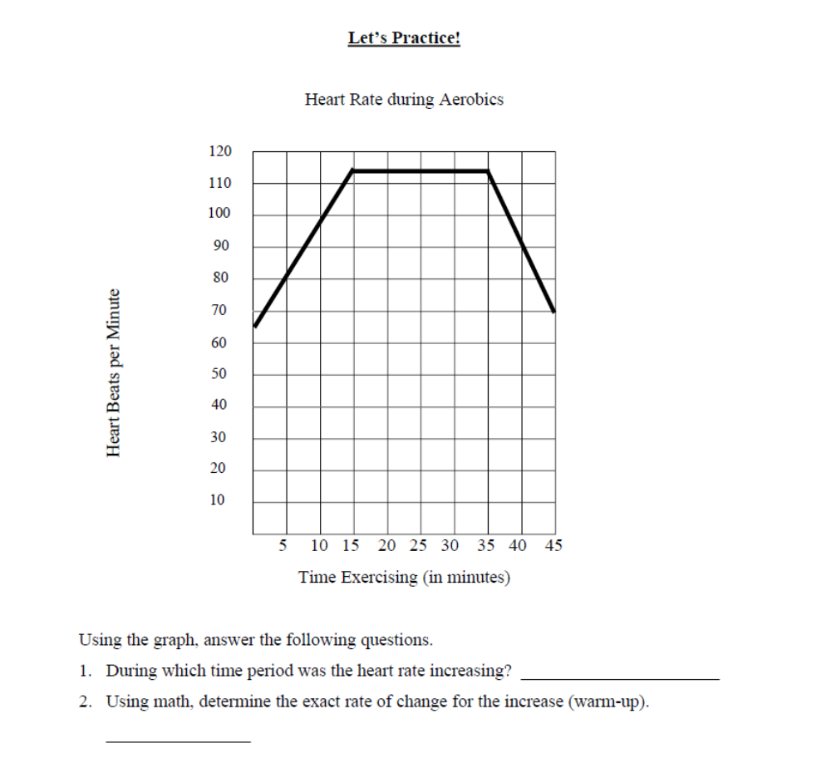
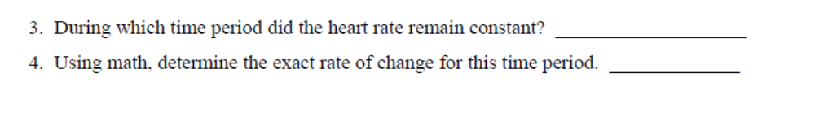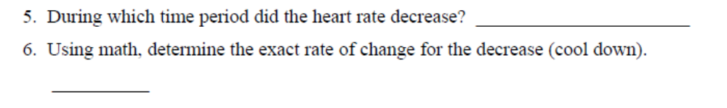

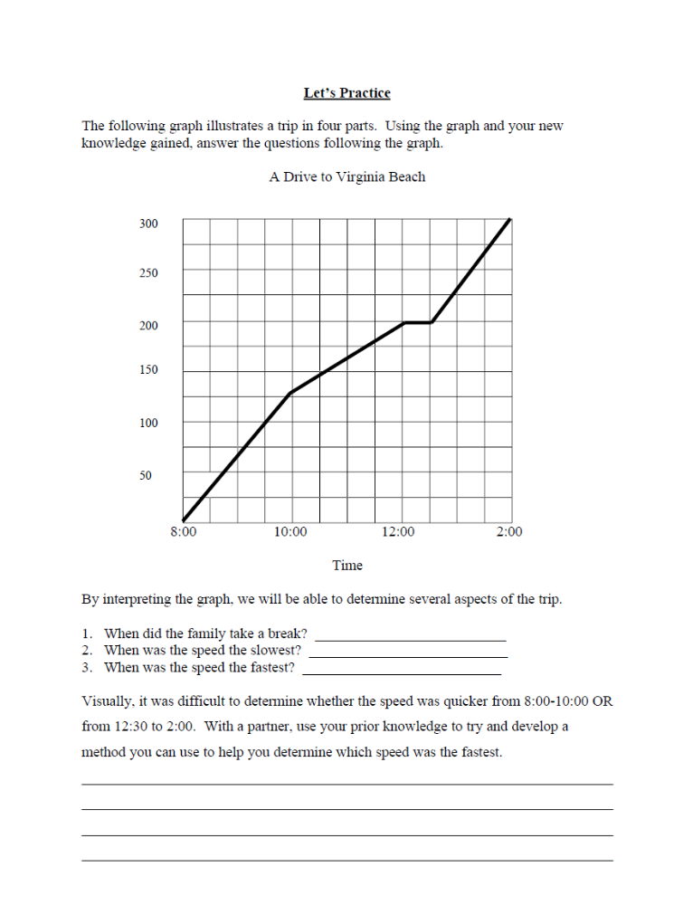

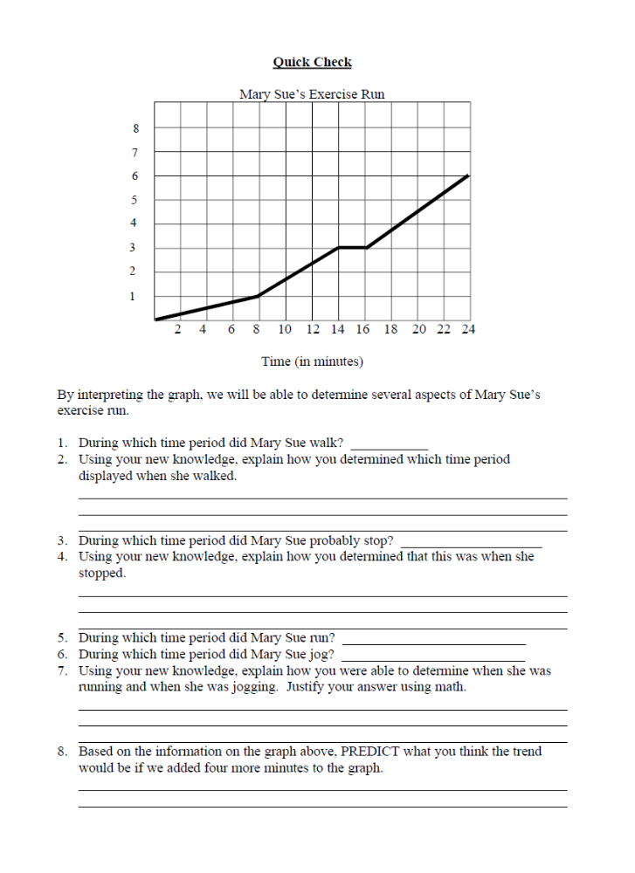
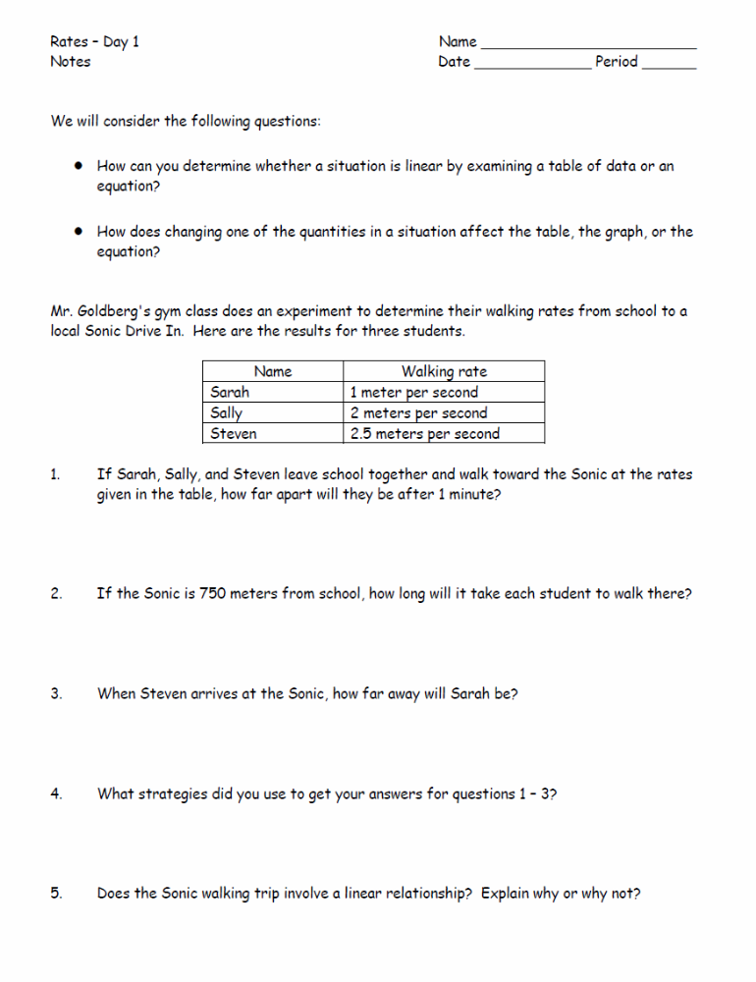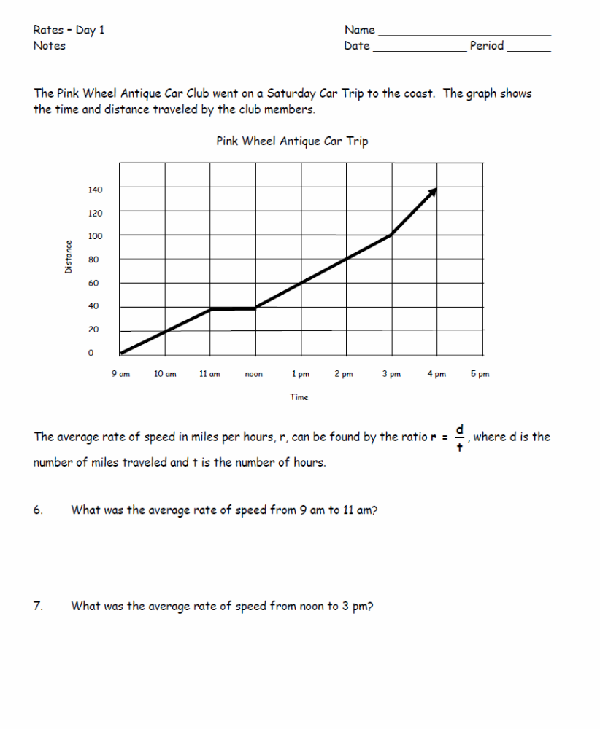

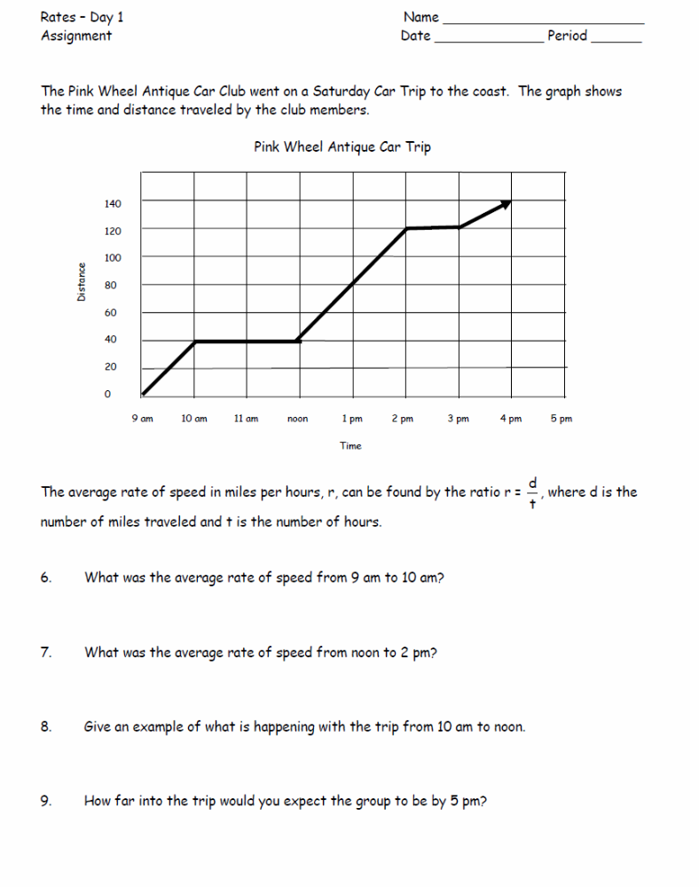

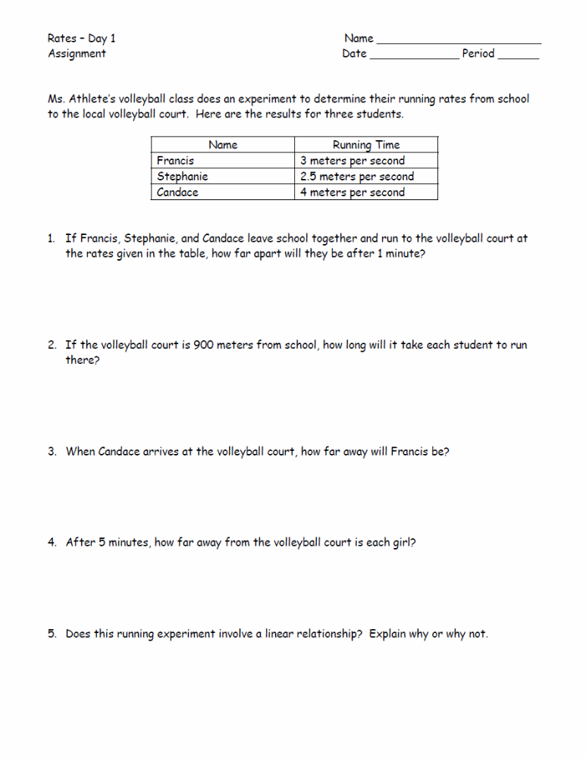
10.
14.
13.
12.
11.

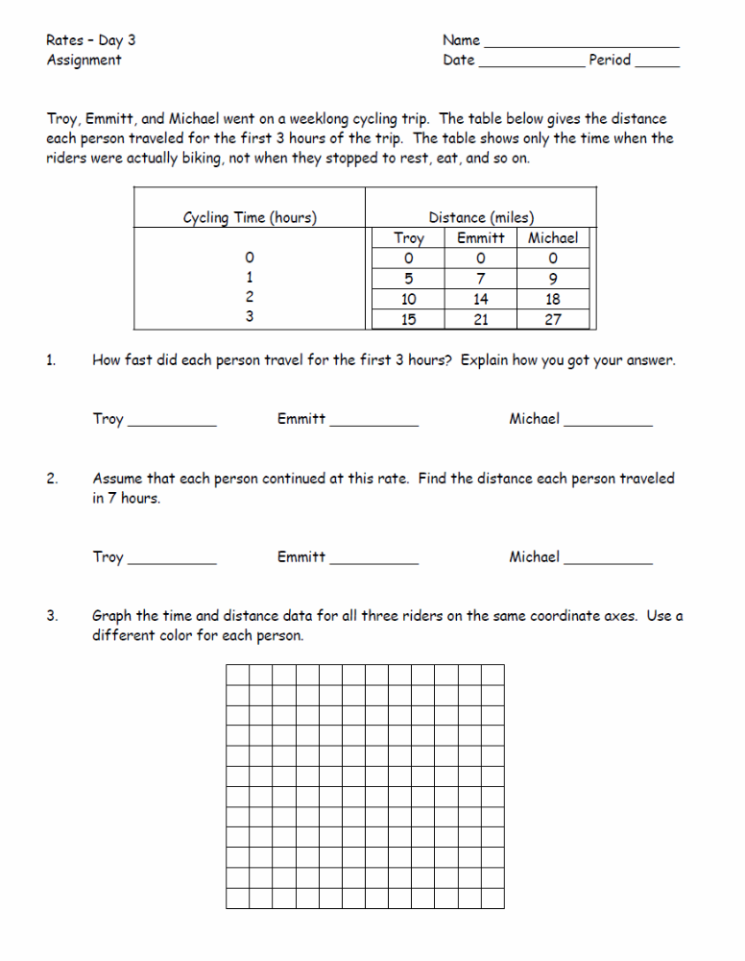

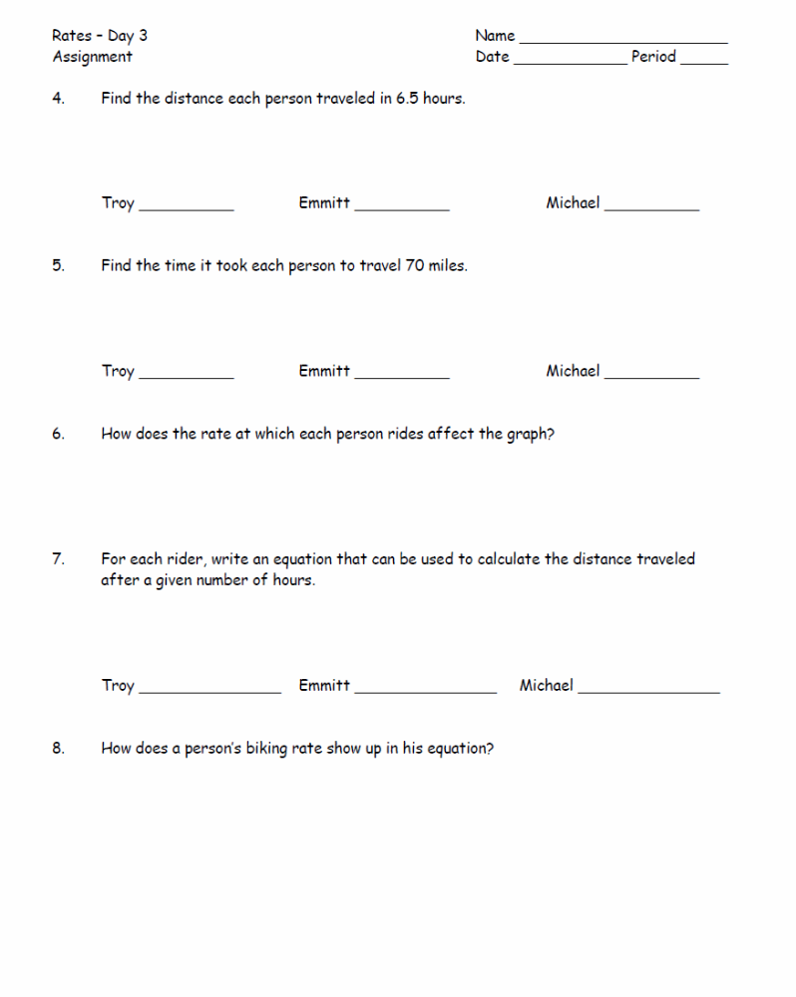

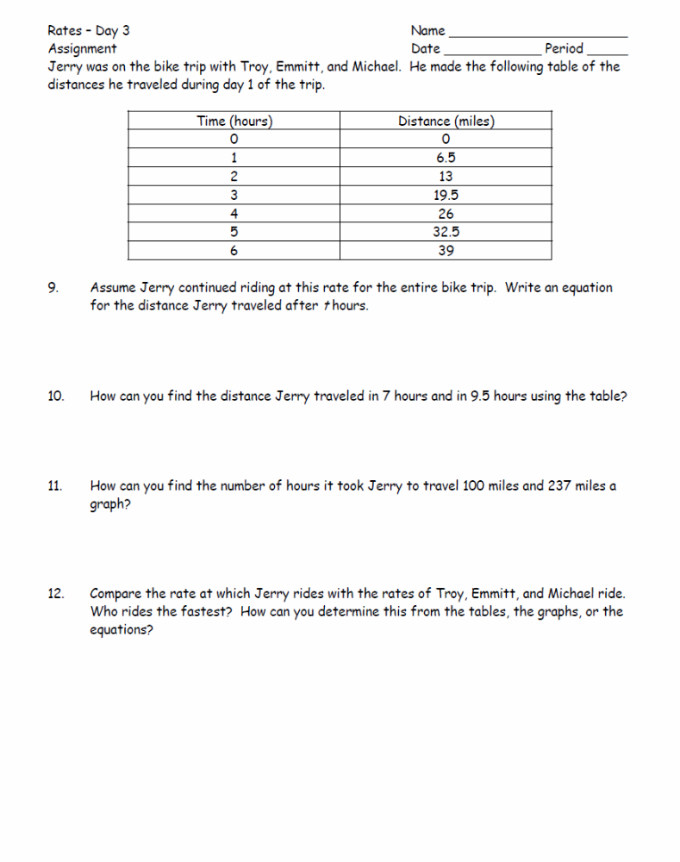
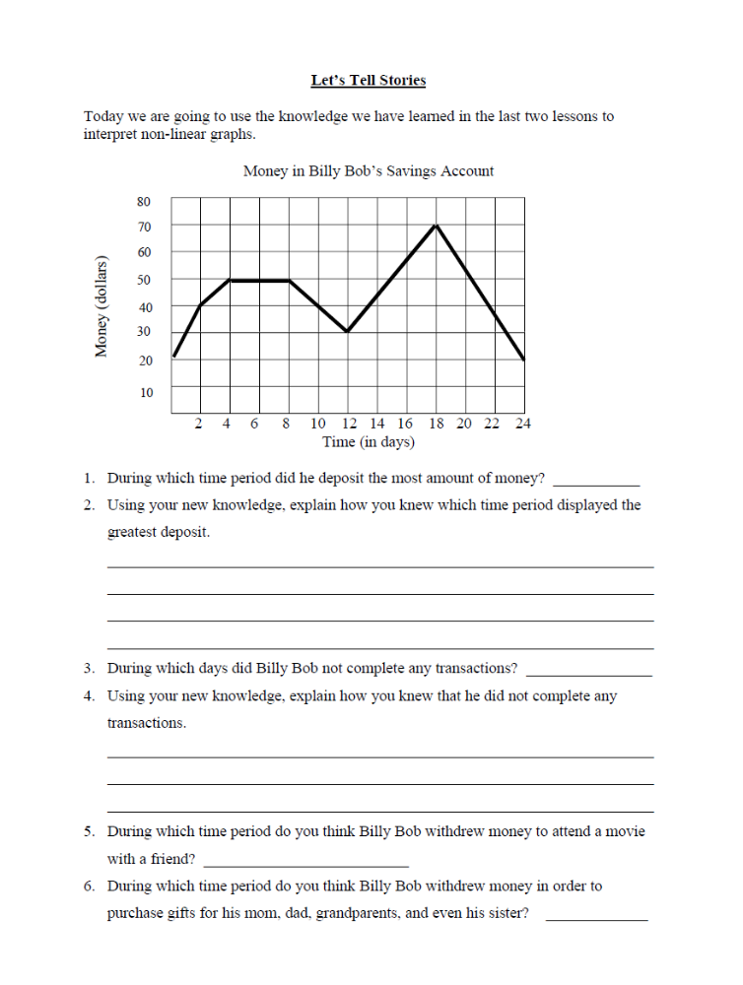

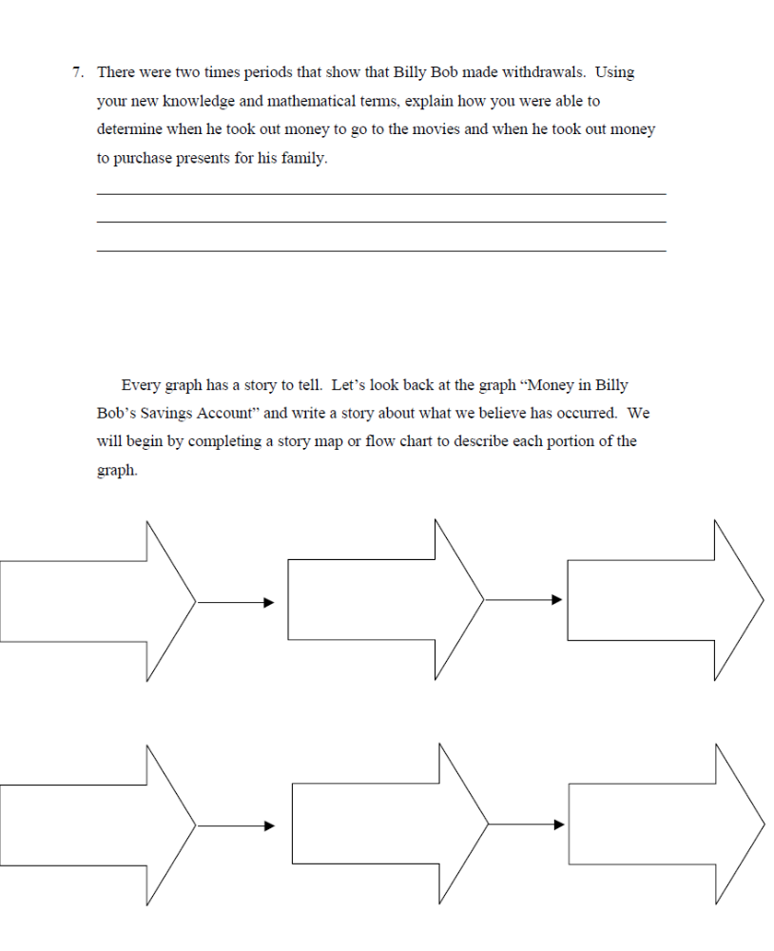

The Slope Formula
Types of Slopes

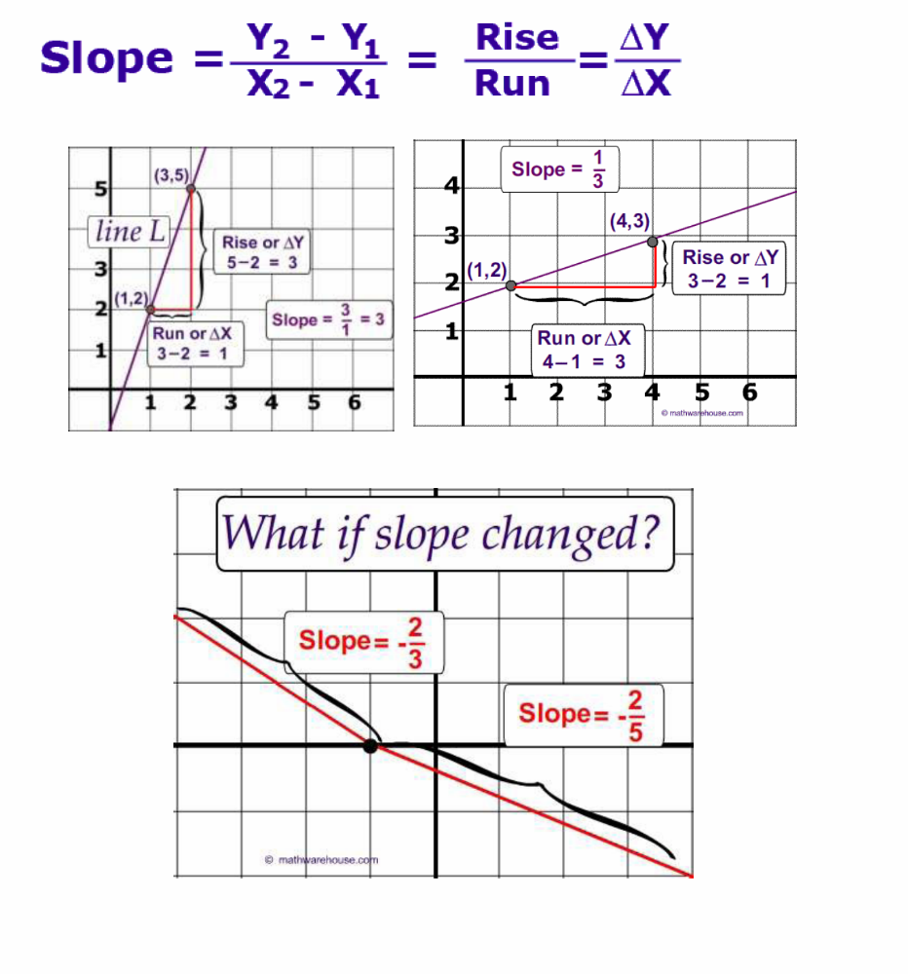

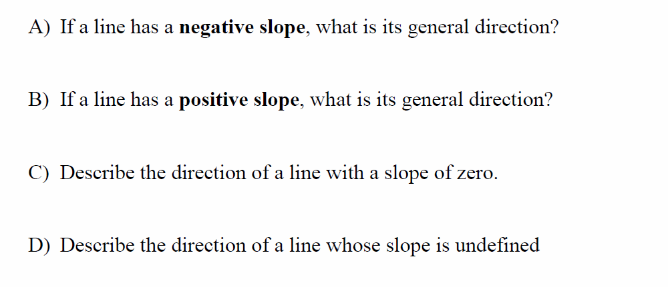

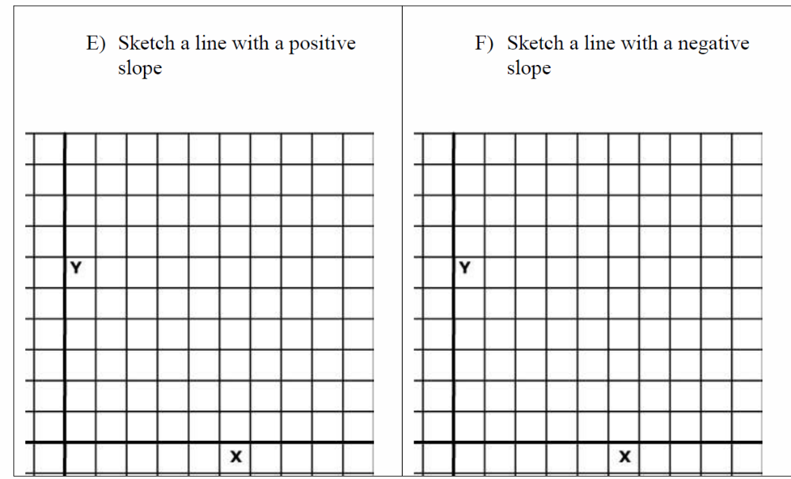
A. Sketch line with a negative slope
B. Sketch line with a positive slope
A. Sketch line with an undefined slope
C. Sketch line with a zero slope

Calculating Slope

Method 1: From the 1st point (the point on the left), count up and over to the 2nd point. The up goes on top of the over in the fraction.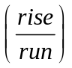

Examples: Find the slope between the two points.

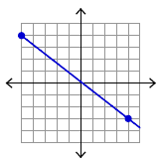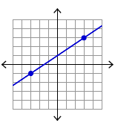

Notes:
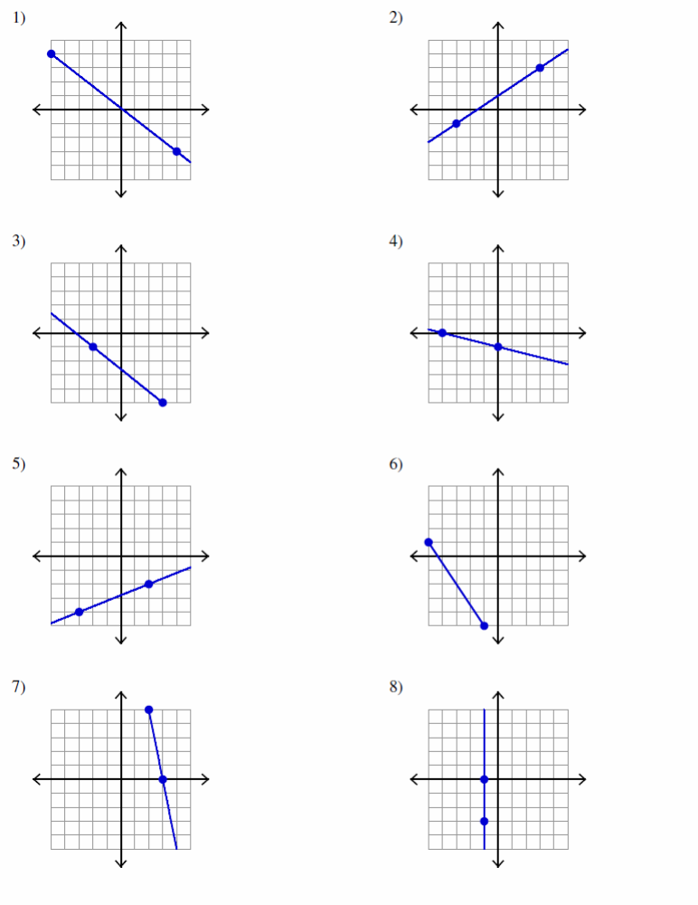

(3,2) (4,1)
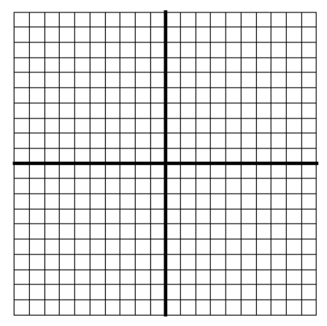
Slope = 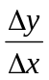 ____

( 1,5) ( 0, 3)
Slope = ____

( 4,3) ( -1, 6)
Slope = ____
( 7, -4) (-1, -3)
Slope = ____
(5,2) (-3,-5)
Slope = ____

( 0,0) ( 5, 2)
Slope = ____

( 2,1) ( -1, 1)
Slope = ____

( 5,2) ( 5, -1)
Slope = ____

Method 2: Slope from a Table:
Pick any two points from the table and calculate .

Examples :
x | y
-2 | 5
-1 | 8
0 | 11
1 | 14
2 | 17

x | y
-9 | 20
-8 | 17
-7 | 14
-6 | -11
-4 | 5

Notes:
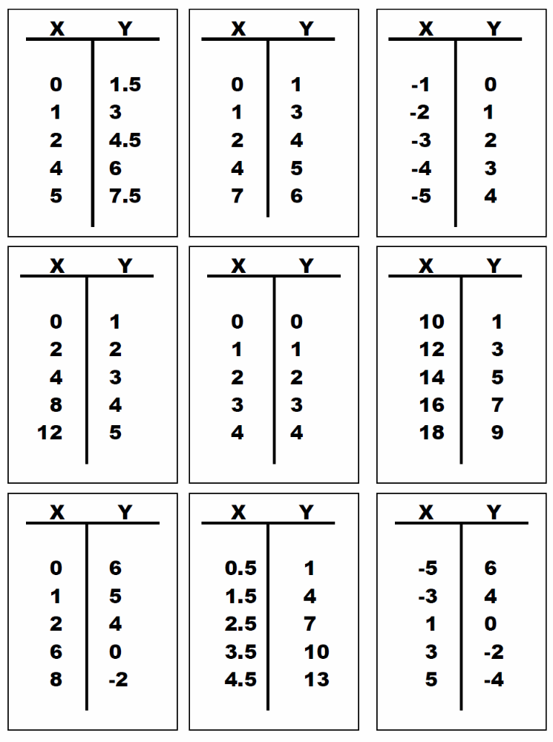

Method 3: Another method that can be used to find the slope of a line given two points is to use the slope formula.

Notes:

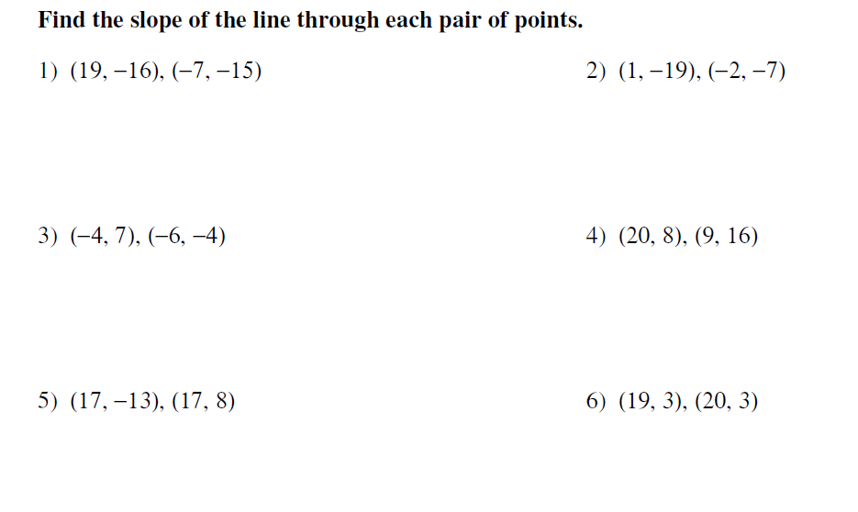

Try some of these now…..

7. ( 1,2) and ( 3, x) slope = 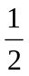
8. (x. -4) and ( 7, 4 ) slope =

- (5, -3) and ( n, 3) slope = 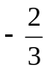
10. (-1, n) and ( 1, -2) slope = -3

Finding Slope from Two Points Practice

Find the slope of the line that passes through the given points.

1. (-1, 3) and (5, 6) slope = 2. (2, 8) and (4, -8) slope=

3. (3, -5) and (7, 5) slope= 4. (0, 4) and (-2, -3) slope=

5. (3, -2) and (-1, 5) slope= 6. (-3, 0) and (-3, 4) slope=

7. (-1, 4) and (2, 4) slope= 8. (0, 2) and (3, n) slope =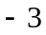

9. (2, -3) and (n, 6) slope= 10. (n, 4) and (2, 0) slope = 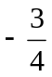

Independent Practice:
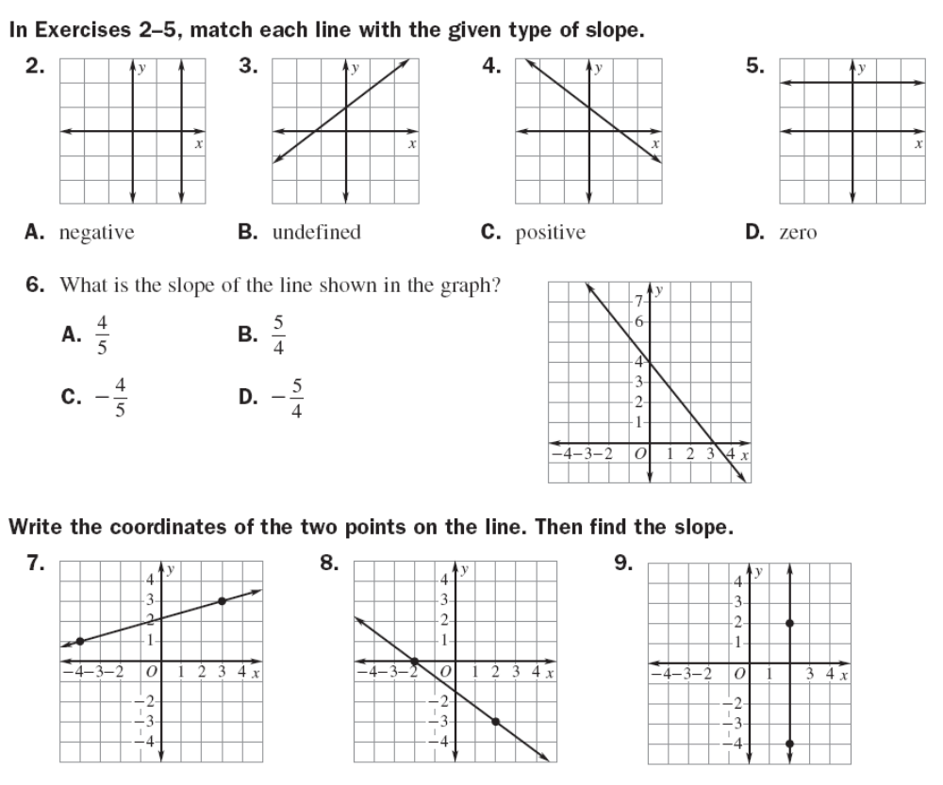

10-13: Write the kind of slope each graph shows (positive, negative, zero, or undefined)
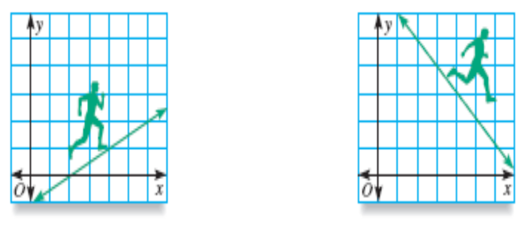
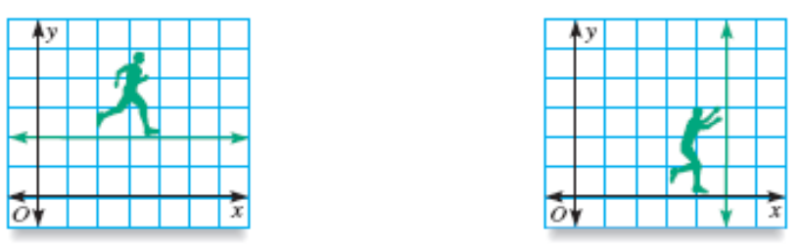

14-16

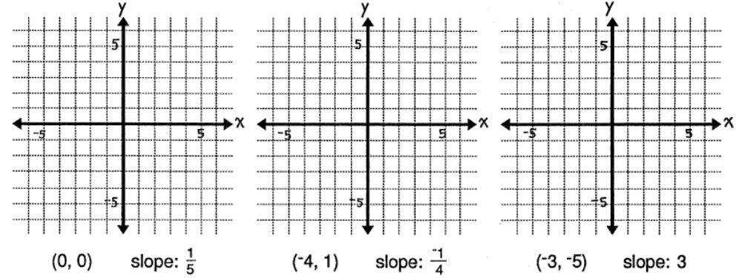

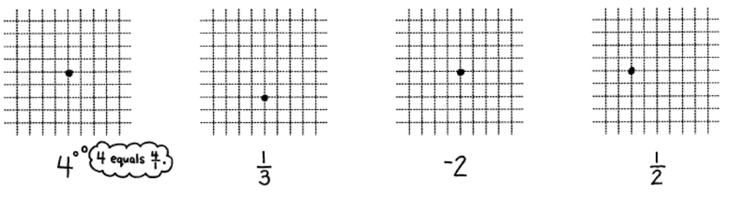
17-20
4

21-26 Find the slope of the containing the following points

(-9, 16) and (-11, 16) | (10, 4) and (7, 4)
(-3, 2) and (1, -4) | (-5, 9) and (3, -3)
(9, -4) and (3, 2) | (-2, 2) and (4, -4)

27- 31 Find the slope from the following tables

27. 28. 29.
X | Y
0 | 2
1 | 5
2 | 8
3 | 11
X | Y
0 | 10
2 | 6
4 | 2
6 | -2
X | Y
-1 | 5
0 | 3
1 | 1
2 | -1

30. 31.
X | Y
-3 | 1
-5 | 4
-7 | 7
-9 | 10
X | Y
-3 | 2
-2 | 4
-1 | 6
0 | 8

Finding Slope Using Tables, Graphs and Points
1.
4.
3.
2.
7.
6.
5.
8.

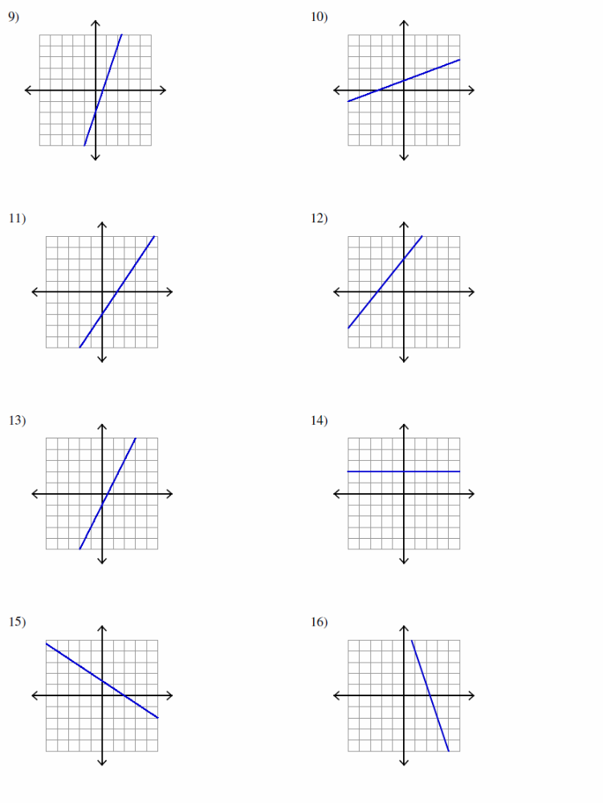

9. (-3,-4) (-1,-6)
Slope = ____

10. ( -1,0) ( 5, 3)
Slope = ____

11. ( 3,-2) ( -1, 6)
Slope = ____
12. ( 7, -5) (6, 2)
Slope = ____
13. (4,3) (-3,-2)
Slope = ____

14. ( 0,2) ( 4, 10)
Slope = ____

15. ( -1,5) ( 3, 5)
Slope = ____

16. ( -4,-3) ( -4, 1)
Slope = ____

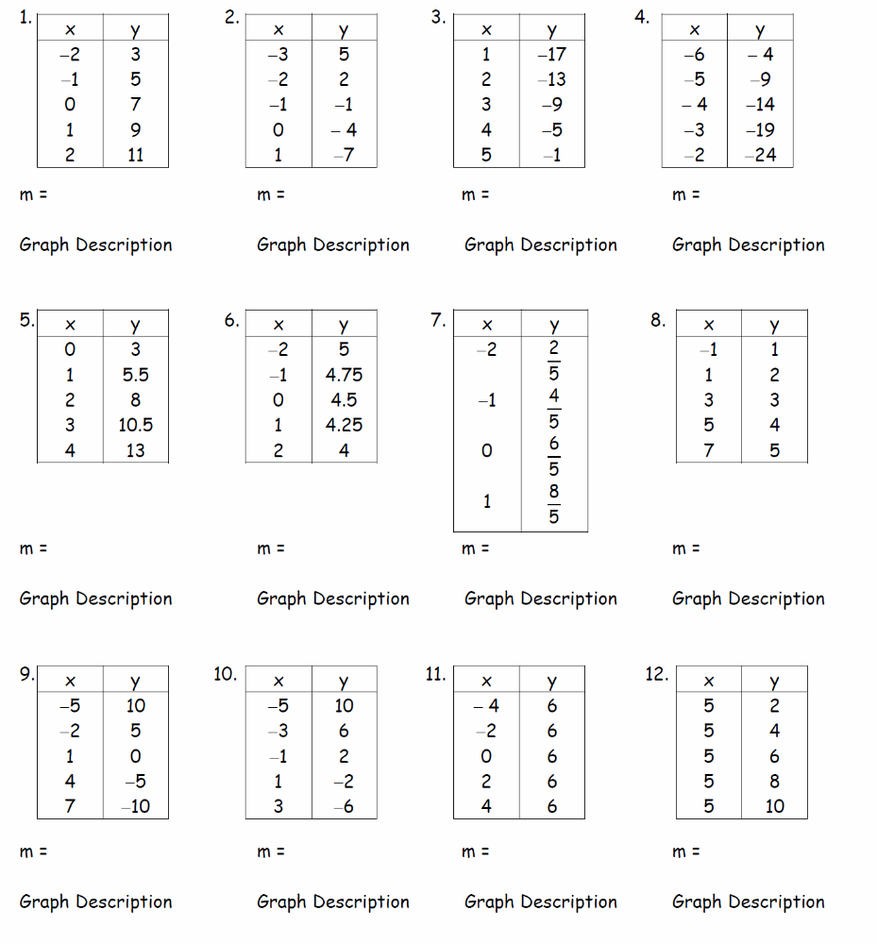
17.
22.
21.
18.
19.
20.
27.
26.
25.
24.
23.
28.

Slope = ____

29. ( 3,2) (4,1)

Slope = ____

30. ( 1,5) ( 0, 3)

Slope = ____

31. ( 4,3) ( -1, 6)

Slope = ____

32. ( 7, -4) (-1, -3)

Slope = ____
33. (5,2) (-3,-5)

Slope = ____

34. ( 0,0) ( 5, 2)

Slope = ____

35. ( 2,1) ( -1, 1)

Slope = ____

36. ( 5,2) ( 3, 2)

Finding Slope Real World Applications Name __________________________
Activity Date ________________ Period _____

How can you find the slope of a line if all you know are two points on the line?

Horatio recently signed up with an Internet provider. He knows that there is a basic monthly charge and an hourly rate depending on how many hours he is connected during the month. The first month he was connected for 5 hours and his bill was $25.00. The second month he was connected for 8 hours and his bill was $31.00. He has forgotten what the hourly rate is.
Time (hr)
Total fee ($)
time₁ 5
$25.00 cost₁
8 time₂ ti time₂ 8
$31.00 cost₂

- What is the difference between the number of hours he was connected for the two months?

- What is the difference between the costs of the monthly bills?

- What is the hourly rate?

- On graph paper mark the vertical axis from 0 to 35 and the horizontal axis from 0 to 9. Then plot the points (5, 25) and (8, 31). Describe the real-world meaning of these points.

- Draw a right triangle using the segment that connects the two points as the hypotenuse. How long is the vertical segment? How long is the horizontal segment?

- Write a symbolic algebraic rule for finding the slope between any two points (x₁, y₁) and (x₂ , y₂). To do this think about what you did in question 3 with the numbers in the table andwrite an expression that shows the same operations done on the variables.

- Find the slope of the line containing the points (2, 2) and (8, 6).

- Graph the points, draw the line through the points, and verify that the point (5, 4) is on that line.

- Use the slope you found in number 1 to find the coordinates of two other points on the line.

9 . Find the slope of the line through each pair of points. Name another point that lies on the
same line.

a. (2, 4), (4, 7) b. (6, −1), (2, 5)

c. (−3, 5), (−2, 8) d. (2, −3), (8, 6)

Sally is on the bowling team and needs to practice for the big tournament. The shoe rental is $2 and the cost of each game is $3. Make a table showing the cost for any number of games Sally bowled during a practice session. Graph the data from the table and draw a trend line.


x: | y:

10. Using the graph, find the slope of the line.

11. How can the values in the table be used to find the slope of the line?

12. Based on the trend line, what would be a reasonable domain for this situation?

13. Based on the trend line, what would be a reasonable range for this situation?

At noon, the temperature was 12˚ F. For the next six hours, the temperature fell by an average of 3˚ F an hour. Make a table showing the change in temperature for six hours.

x: | y:

14. Using the table, find the slope of the line.

15. What would be a reasonable domain for this situation?

16. What would be a reasonable range for this situation?

Graph a line that meets the given conditions.
Has a slope of 4 and a starting point of (1,2).  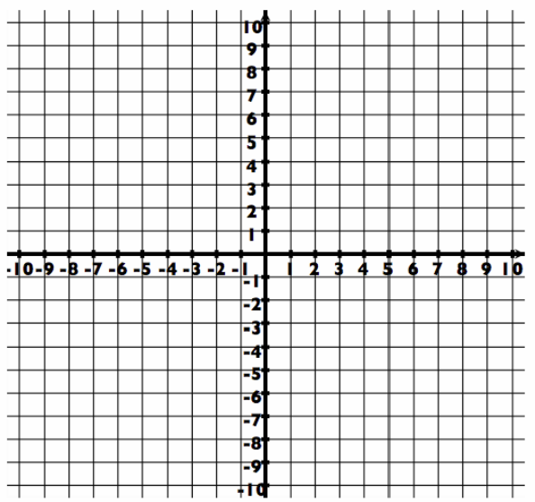 | Has a slope of  and a starting point of (2,-3).
Has a slope of -2 and a starting point of ( 5, 0) . | Has a slope of 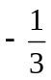 and a starting point of ( 4,-2 ).
Has a slope of 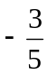 and a starting point of ( 1, 7 ). | Has a slope of 3 and a starting point of ( -1 – 6).

Has a slope of 2 and a starting point of (-6,2). | Has a slope of 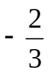 and a starting point of (0, -1).
Has a slope of 3 and a starting point of ( 1,2 ) . | Has a slope of and a starting point of ( 4, 3 ).
Has a slope of  and a starting point of ( 2, -3 ). | Has a slope of 2 and a starting point of ( 3, 3 ).

Has a slope of 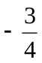 and a starting point of (0, 0). | Has a slope of and a starting point of (3, 2).
Has a slope of 2 and a starting point of ( 3, 1 ) . | Has a slope of -3 and a starting point of ( 4,-2 ).

Has a slope of 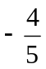 and a starting point of ( 0, 3 ). | Has a slope of 1 and a starting point of ( 1 , –3).

Classwork:
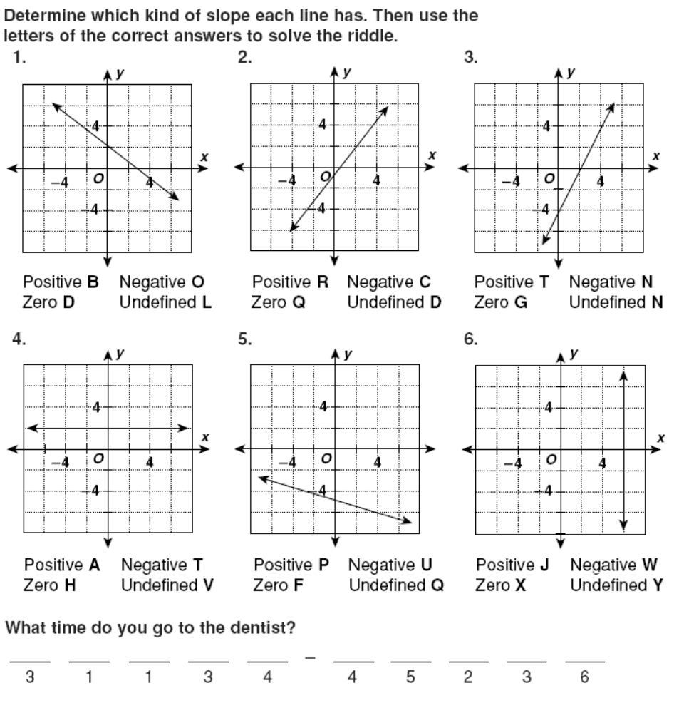

Find the slope of each line shown.

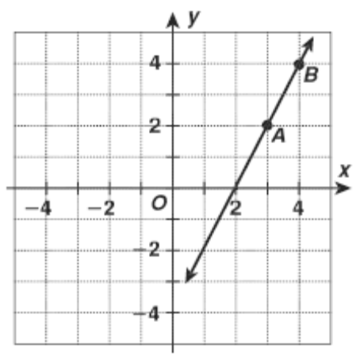
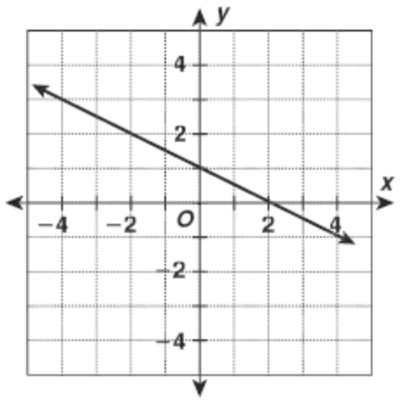
7.) 8.)

Slope: ______________ Slope: ______________
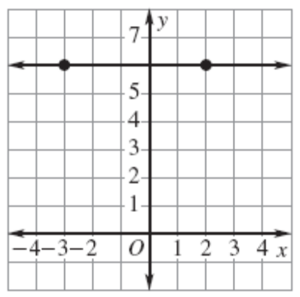
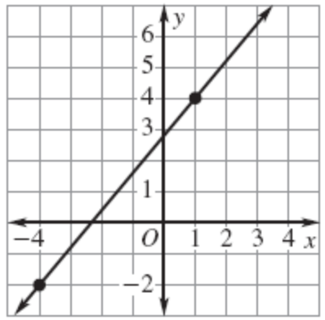
8.)
9.)

Slope: _________ Slope: _________

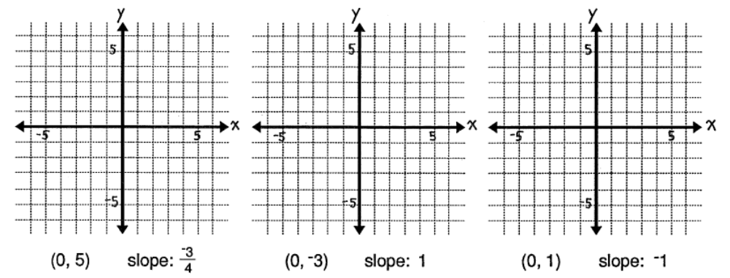
10.)
11.)
12.)

13 - 17 Use the following points to find the slope of the line.

13. (9, 6) and (1, 4) 15. (1, 2) and (2, 4) 17. (-1, -3) and (1, -2)

14. (4, 3) and (8, 4) 16. (-3, -1) and (6, -4)

18- 20 Find the slope from the following tables

18. 19. 20.
X | Y
-3 | 2.5
-2 | 1
-1 | -.5
0 | -2
X | Y
-3 | 2
-2 | 4
-1 | 6
0 | 8
X | Y
-3 | 1
-3 | 5
-3 | 9
-3 | 13

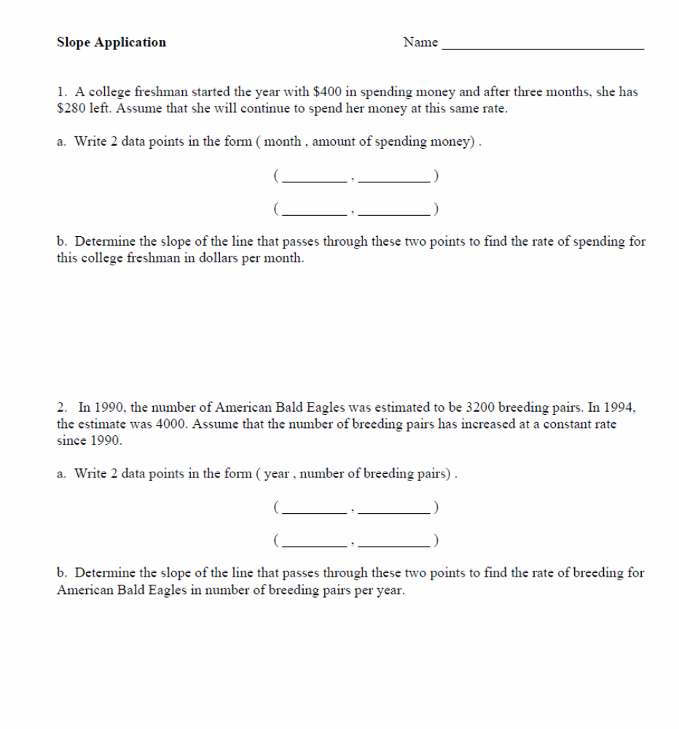

Slope Applications

1. A climber is on a hike. After 2 hours he is at an altitude of 400 feet. After 6 hours, he is at an altitude of 700 feet. What is the average rate of change?

- Write 2 data points in the form ( hours , altitude) .

( _________ , __________ )
( _________ , __________ )

- Determine the slope of the line that passes through these two points to find the rate of the
climber going up the mountain.

2. A scuba diver is 30 feet below the surface of the water 10 seconds after he entered the water and 100 feet below the surface after 40 seconds. What is the scuba divers rate of change?

- Write 2 data points in the form ( seconds , depth ) .

( _________ , __________ )
( _________ , __________ )

- Determine the slope of the line that passes through these two points to find the rate of the
Scuba diver descending..

3. A rocket is 1 mile above the earth in 30 seconds and 5 miles above the earth in 2.5 minutes. What is the rockets rate of change in miles per second? What about miles per minute.

- Write 2 data points in the form ( seconds , miles ) .

( _________ , __________ )
( _________ , __________ )

- Determine the slope of the line that passes through these two points to find the rate that the Rocket leaves earth.

4. A teacher weighed 145 lbs in 1986 and weighs 190 lbs in 2007. What was the rate of change in weight?

- Write 2 data points in the form ( year , weight) .

( _________ , __________ )
( _________ , __________ )

- Determine the slope of the line that passes through these two points to find the rate that the teacher gained weight.

5. . After 30 baseball games, A-Rod had 25 hits. If after 100 games he had 80 hits, what is his average hits per baseball game.

- Write 2 data points in the form ( games , hits ) .

( _________ , __________ )
( _________ , __________ )

- Determine the slope of the line that passes through these two points to find average hits per baseball game

6. Michael started a savings account with $300. After 4 weeks, he had $350 dollars, and after 9 weeks, he had$400. What is the rate of change of money in his savings account per week?

- Write 2 data points in the form ( weeks , money ) .

( _________ , __________ )
( _________ , __________ )

- Determine the slope of the line that passes through these two points to find the rate of change of money in his savings account per week.

A.6 Linear functions. The student understands the meaning of the slope and intercepts of the graphs of linear
functions and zeros of linear functions and interprets and describes the effects of changes in parameters of linear functions in real-world and mathematical situations
(A) The student develops the concepts of slope as a rate of change and determines slopes from graphs, tables, and algebraic representations.

2003 9th Grade
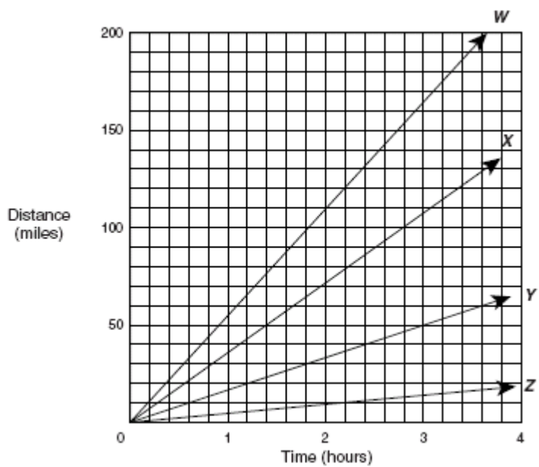
39) In the distance formula d = rt, r represents the rate of change, or slope. Which ray on the graph best represents a slope of 55 mph?

A W
B X
C Y
D Z

2004 9th Grade
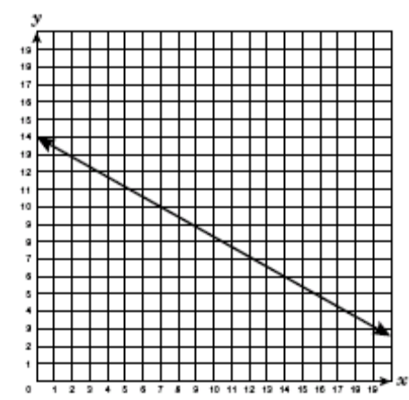
19) What is the slope of the linear function shown in the graph?

A − 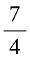
B −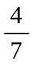
C
D

2006 9th Grade
17) What is the slope of the line that contains the coordinate points (8, −3) and (−2, 7)?
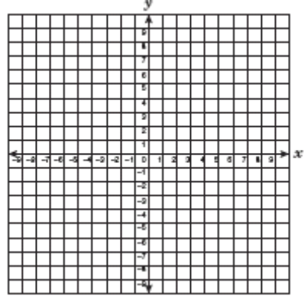
A −1
B −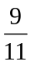
C −
D −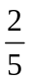

A.6.A The student develops the concepts of slope as a rate of change and determines slopes from graphs, tables, and algebraic representations.

2003 10th Grade
46) What is m, the slope of the line that contains the points
(2, 0), (0, 3), and (4, −3)?

F m =  H m = −

G m = J m = −

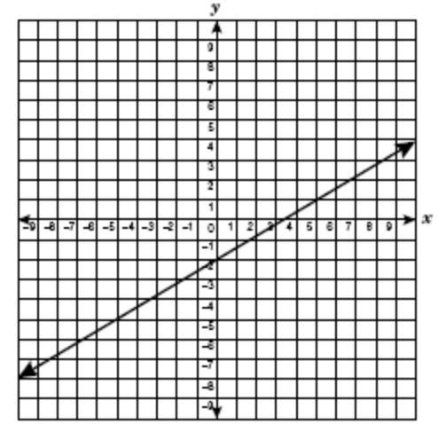
2004 10th Grade
26) What is the rate of change of the graph below?

F 3.5
G 1.67
H 0.6
J −1.67

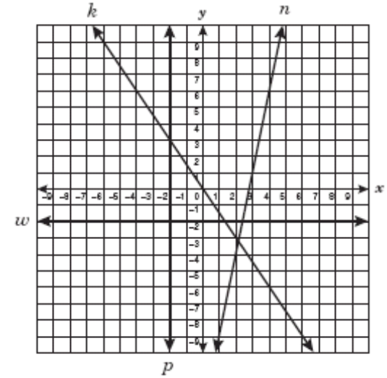
2006 10th Grade
40) Which line appears to have a slope of zero?

F Line n
G Line k
H Line w
J Line p
A.6.A The student develops the concepts of slope as a rate of change and determines slopes from graphs, tables, and algebraic representations.

2006 Summer Exit
15) What is the apparent slope of the line graphed below?

A −
B
C
D −

2008 Released Exit
8) Which of the following tables best represents a linear function with a rate of change of 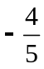?
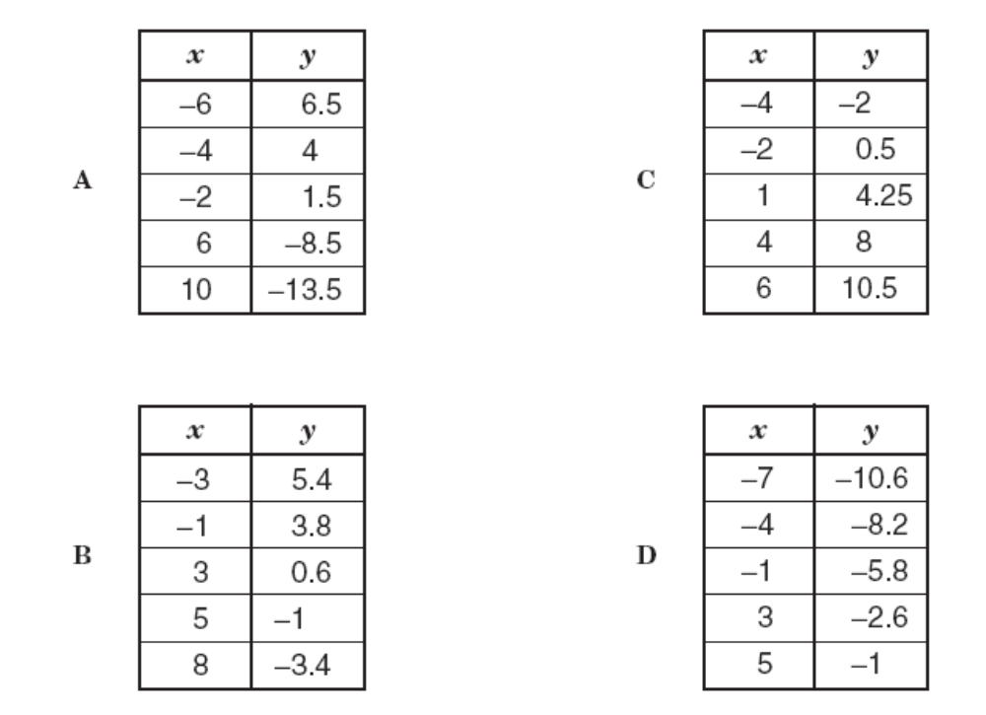
A B C D

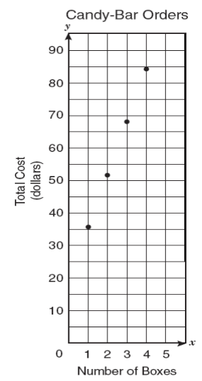
2010 Released Exit
8) Mr. Czar wants to order some candy bars for the math team’s annual fund-raiser.
The graph below shows the total cost for an order of fewer than 5 boxes of candy bars,
including the standard fee for shipping and handling.
Based on the graph, which of the following best describes this situation?

A Each box of candy bars costs $36.
B Each box of candy bars costs $20.
C Each box of candy bars costs $16.
D Each box of candy bars costs $12.

Finding Slope Given Two Points Name___________________________
Homework Date__________________ Period ____

I. Determine the slope for each line shown.

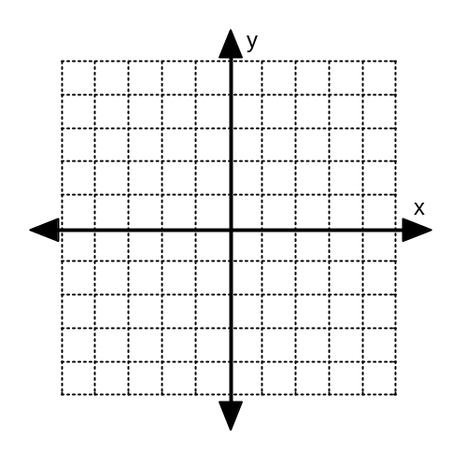
1. m = _________ 2. m = __________ 3. m = __________

II. Determine the slope of the line represented by each table.

4. m = ___________ 5. m = ___________ 6. m = ______________
xy−5
− 4
−31−2
−1
xy−32.5−21−1−0.50−21−3.5
xy−31−35−39−313−317

- Determine the slope of the line that passes through each pair of points.

7. (−3, 1) (2, 5) 8. (− 4, −2) (0, 0) 9. (2, 3) (5, 1)

10. (2, 3) (9, 7) 11. (−3, − 4) (5, 1) 12. (2, 6) (−1, 3)
m = _________ m = _________ m = _________

13. (−5, 4) (−5, −1) 14. (5, 7) (−2, −3) 15. (−2, 3) (8, 3)
m = _________ m = _________ m = ________

16. (−2, 3) (3, −3) 17. (−2, −8) (1, 4) 18. (3, 4) (4, 6)
m = _________ m = _________ m = ________

19. Bob is depositing the same amount of money each week into his account to save for an iPod. After five weeks he has $75 and after eight weeks he has $135. Identify the two points given and find the amount of money he deposited each week. The amount of money he deposited each week is the rate of change.

20. Mary Ellen was confused by her cell phone bills. The first month she was charged $34.25 and the second month she was charged $43.50. After reviewing her statements, she realized that during her first month of service, she exceeded her text message plan by 17 messages and the second month by 54 messages. Identify the two points given and find the cost for each additional text message.

