Algebra I

Unit 1

Algebraic Expressions
And Properties

Name: ____________________

Teacher: _______________

Period: ________

Breaking the Code

Determine what number each letter represents. Each letter represents a different number and the same letters stand for the same numbers within a problem. All numbers are whole numbers.

1. A + B = A

C – A = 6

A + A = 10

D + A = 9

A = __________

B = __________

C = __________

D = __________

2. M · P = 12

6 + P = Q

Q · N = 20

N · R = N

N + R = 3

M = __________

N = __________

P = __________
Q = __________

R = __________

Law and Order

Work each problem without a calculator and record your answer in the first column.

When you are finished, get a calculator and type in each problem as written. Write your answers in the second column.

Problem | Your Answer | Calculator Answer
5• 2 + 3
5 + 3 • 2
(5 + 3) • 2
5 • (2 + 3)
24 + (6 • 2)
24 + 6 • 2
4² – 3
(4 – 3)²
12 • 2 – 3 • 5
(8 – 2)² + 4 • 2
8 – 2² + 4 • 2
16 + 2 – 4 • 2
3 • 2 + 13 – 4 • 8

Did you get the same answers for each problem? __________

How can we assure that every person will always get the same answers to the same problems?

___________________________________________________________________

___________________________________________________________________
Order of Operations

____________________________, ____________________________ and

______________________________are used to write algebraic expressions.

When there is more than one operation, the ______________________________ must be followed.

Please | P______________ |  | ________________  ________________  ________________  ________________
Excuse | E______________ |  | ________________  ________________  ________________  ________________
My Dear | M______________  or  D______________ | ________________  ________________ | ________________  ________________  ________________  ________________
Aunt Sally | A______________  or  S______________ | ________________  ________________ | ________________  ________________  ________________  ________________

Absolute Value

The absolute value of a number is _______________________________________.

Absolute value is NEVER __________________________. Absolute value is

either ______________________ or ______________________.
Algebra I A Name: ___________________
Date: __________ Period: ___

Order of Operations Practice

Use the order of operations to simplify each expression. Write each step on one line.

1. -2(-2 – 3 · 5) – [2(3 – 5) + 2] 2. -(-2)(-3) + (-6)(-1) – 2(-1 – 3 · 4)
__________________ ____________________
__________________ ____________________
__________________ ____________________
__________________ ____________________
__________________ ____________________
__________________ ____________________
__________________ ____________________

3. -[-(3)] – (-2) – 4 + (-6)/3 4. 5 – (4 – 6)2 + 4 · 2
3(-2 – 1)
__________________ ____________________
__________________ ____________________
__________________ ____________________
__________________ ____________________
__________________ ____________________
__________________ ____________________
__________________ ____________________

5. 2² + 2³[3²(6 – 5)(2⁴ – 3 · 5)] 6. 4 · 8 ÷ 2 · 6 ÷ 3

__________________ ____________________
__________________ ____________________
__________________ ____________________
__________________ ____________________
__________________ ____________________
__________________ ____________________
__________________ ____________________

7. bc – ab if a = -3, b = 2, c = -1 8. xy² + yx² + x³y – xy if x = 2, y = 3
__________________ ____________________
__________________ ____________________
__________________ ____________________
__________________ ____________________
__________________ ____________________
__________________ ____________________
__________________ ____________________

9. ⅓(½ · ⅓ – ¾ · ½) 10. 7 – (2 – 4)² + 5 · 1
4(-2 + 3)
__________________ ____________________
__________________ ____________________
__________________ ____________________
__________________ ____________________
__________________ ____________________
__________________ ____________________
__________________ ____________________

11. -2²(2 · 2 – 3 · 2) – 3(2 · 3 – 2²) 12. -3 – 2(3 · 2 – 1) + 2²
2²(-3 – 2²)
__________________ ____________________
__________________ ____________________
__________________ ____________________
__________________ ____________________
__________________ ____________________
__________________ ____________________
__________________ ____________________

13. -3² – (-3)² 14. -2² – (-2)³
__________________ ____________________
__________________ ____________________
__________________ ____________________
__________________ ____________________
__________________ ____________________

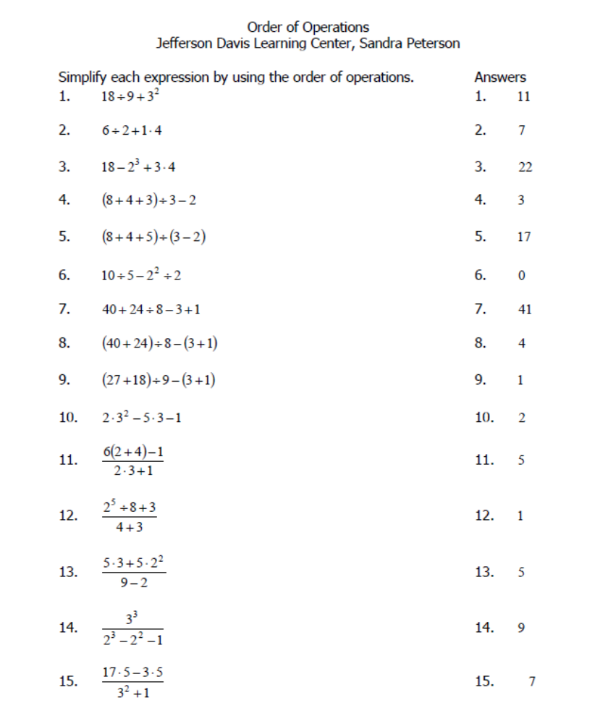
Order of Operations Worksheet

Order of Operations Homework

1. 3 + 2 • 5 = __________ 2. 7 – 3 • 5 = __________

3. 36 ÷ 4 + 2 = __________ 4. 12 + 18 ÷ 6 – 3 • (-2) = __________

5. (8 – 4)3 + 12 = __________ 6. (7 + 2)(-3) + 9 = __________

7. 14 – 7(4 + 2) = __________ 8. 25 ÷ 5 + (7 + 3)2 = __________

9. 3(8 – 6) + 42 ÷ 7 = __________ 10. [2 + (3 – 5)6] ÷ (5 • 8 – 10) = __________

11. [4 • (8 – 2 • 3) + 7] – (16 ÷ 2 + 6) = __________

12. 4(3 + 2) – 5[(7 – 4)2 + 8 ÷ (4 – 6)] = __________

13. (5 + 2²)²= __________ 14. 2(5 + 3)² = __________

15. 6(5 + 12 ÷ 6)² 16. 5[(6 – 3)² + 4 • 2] = __________

17. 26 – 6 • 2 = __________ 18. 2 + 5 • 4 = __________
10 + 16 ÷ 4 2 • 3 – 17

19. (5 – 3)4 = __________ 20. (3 – 5 • 2³ + 1) ÷ 9 = __________
6 • 4 – 12 (5 – 6)³ + 6 ÷ 2

21. -48 ÷ │-12│ = __________ 22. │-11│ = __________

23. │-20│ = __________ 24. │28│ = __________

25. 14 – │-29│ = __________ 26. │-3│ – │-10│ = __________

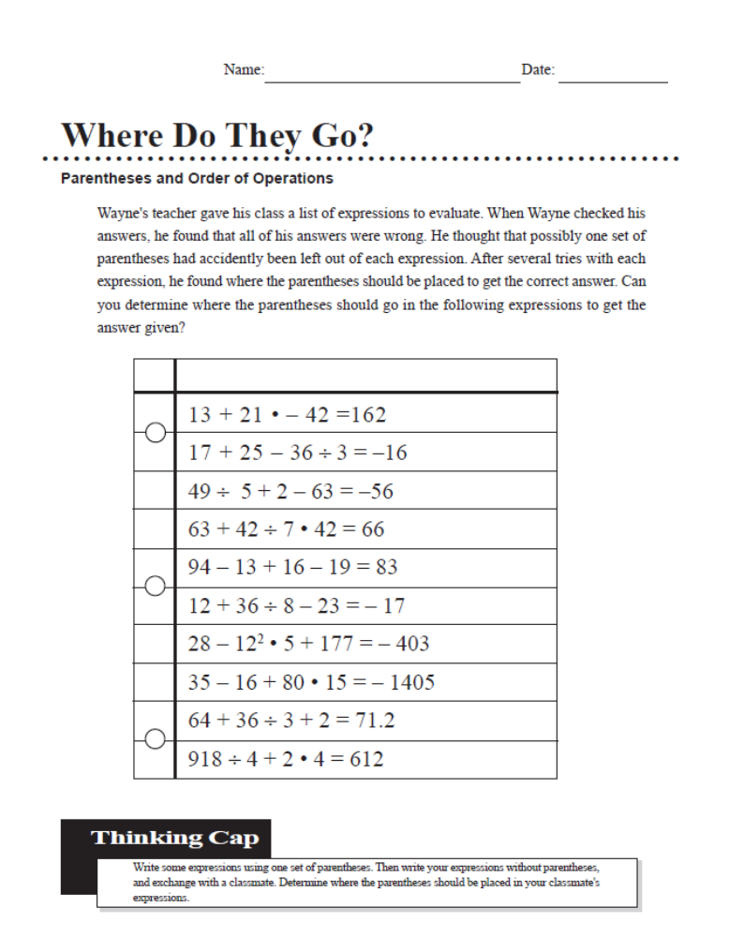

Introduction to Translation Notes

Complete the following chart to review key words in verbal phrases and their corresponding mathematical symbols.

Operation | Verbal Phrase | Algebraic Expression
___________________ | • The sum of five and a number  • Six more than a number  • A number increased by four  • A number plus eight | ____________________  ____________________  ____________________  ____________________
____________________ | • The difference of five and a number  • Six less than a number  • A number decreased by four  • A number minus eight | ____________________  ____________________  ____________________  ____________________
____________________ | • The product of five and a number  • Six times a number  • A number multiplied by eight | ____________________  ____________________  ____________________
Operation | Verbal Phrase | Algebraic Expression
____________________ | • The quotient of five and a number  • Six divided by a number  • The quotient of a number and eight | ____________________  ____________________  ____________________
____________________ | • The square of a number  • The cube of a number | ____________________  ____________________
____________________ | • Half the sum of five and a number  • The cube of the difference of a number and seven  • The quotient of the sum of a number and five and the difference of a number and eight | ____________________  ____________________  ____________________

Translation Game
Phrase | Answer | Phrase | Answer
1  The sum of a number and three |  | 10  Twice the cube of a number
2  The sum of five times a number and seven |  | 11  The square of the product of a number and three
3  The sum of twice a number and twenty-seven |  | 12  The quotient of a number and eight
4  Twice the sum of a number and twenty-seven |  | 13  Five less than the quotient of a number divided by nine
5  Eight less than six times a number |  | 14  The sum of seventeen and the quotient of a number divided by 8
6  Five times the difference of a number and six |  | 15  A number decreased by nine
7  Nine more than the square of a number |  | 16  Twice the difference of a number and six
8  The difference of two and the cube of a number |  | 17  Five times the difference of 12 and a number
9
The square of the sum of a number and four
Translating Algebraic Expressions Practice

1. The product of two different numbers and 3 __________________

2. Half the sum of 7 and a number __________________

3. 8 more than 5 times the cube of a number __________________

4. A number minus six cubed __________________

5. The difference of 56 and a number __________________

6. A number less than 45 __________________

7. The quotient of 80 and the difference of two numbers __________________

8. A number squared __________________

9. Twice a number subtracted from 54 __________________

10. A number subtracted from the square of the same number. __________________

11. Decrease the opposite of a number by 11 __________________

12. 27 divided by twice a number __________________

13. The square of the difference of a number and 5 __________________

14. The cube of the sum of a number and 2 __________________

15. The sum of a number and three times its square __________________

16. Six times the difference of two numbers __________________

17. The quantity of a number plus 3 squared __________________

18. The quotient of a number and 7 is decreased by 5 _________________

Evaluating Variable Expressions Notes

A ___________________________________________________ is made up of:

- _________________________________________________________
- _________________________________________________________
- _________________________________________________________

The ____________________ Property states ___________________________
________________________________________________________________

We evaluate variable expressions by:
a. ___________________________________________________________
- __________________________________________________________
- ___________________________________________________________

Examples: Evaluate for the given value(s).

a. (b – a)² + c , for a = -2, b = 3, c = 4 b. p – (5 + m), for m = 4, p = 10

c. -8 + a, for a = 25 d. (-2h)⁴, for h = -1

Complete the following table for each expression with its replacement set.

e. f.
a | 5a² + 6
-2
-1
3
4

y | 3y – 2
-2
-1
3
4

g. 5(n – 12), for n = -4 h. -[-(3x – 5) + x], for x = -9

i. a² - 4a + 8, for a = 5 j. -¾ a, for a = 48

k. |-15 – t| , for t = -11 l. |-3b + c| -5, for b = 2, c = -13

Evaluating Variable Expressions Practice

Evaluate for the given value(s).

1. |p + 7| for p = -13 2. -2 |-6x| for x = 5

3. y² + 3y + 2 for y = 5 4. -11 – k(h + 1) for h = -5, k = 9
y + 2

5. y + x for x = -5, y = -12 6. r – s for r = -16, s = -12
- -4

7. 3(a – b) for a = 8, b = 11 8. w(8 – z) for w = -2, z = 3
b – a wz + 1

9. _ n + p for n = -3, p = -9 10. -n + 7p for n = -16, p = 4
n

11. x + 3y for x = -12, y = -3 12. -11 + 4r for r = -5

Finding the Value

Write the expressions, then, evaluate.

1. a. the product of 5 and a number x ___________________________

b. evaluate when x = -1. _________________

2. a. 18 decreased by a number z ___________________________

b. evaluate when z = 23 __________________

3. a. the quotient of 16 and a number m ___________________________

b. evaluate when m = -4 __________________

4. a. the product of 8 and twice a number n __________________________

b. evaluate when n = 3 ___________________

5. a. the sum of 3 times a number k and 4 ____________________________

b. evaluate when k = -2 ____________________

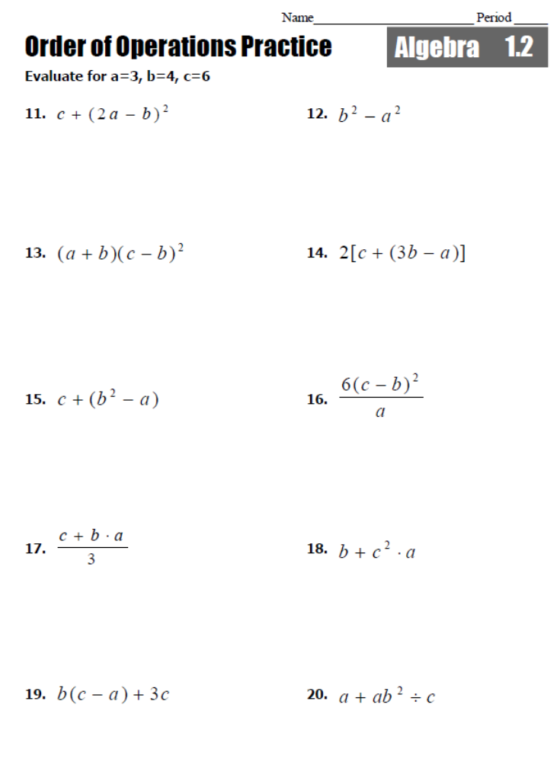
6.
5.
41.
3.
2.
8.
7.
9.
10.

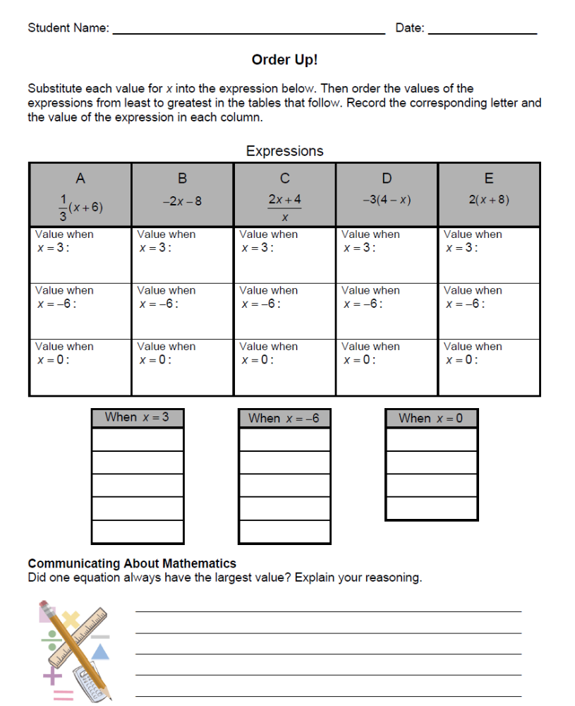

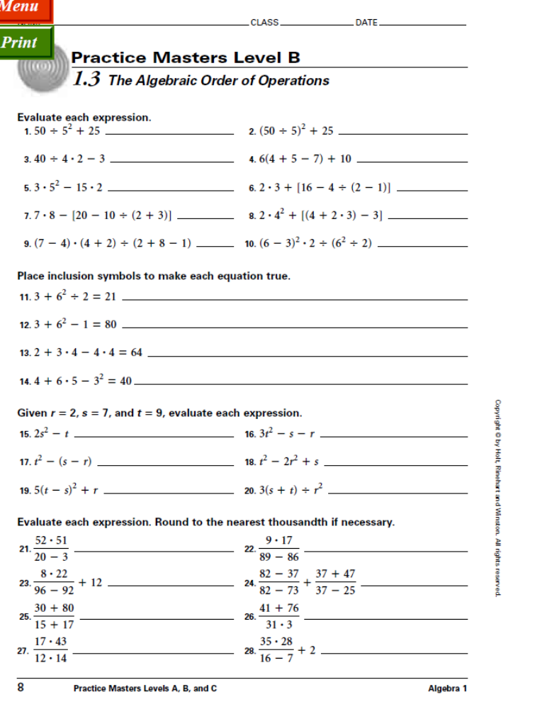

Translating Word Problems

When asked to translate a word problem into a variable expression, look for a pattern. The part of the pattern that changes should become your______________.

Example 1: Jason is going dancing. The dance club charges $8 at the door and $1.25 for each soft drink. Write an expression for the amount of money Jason should bring, based on the number of soft drinks he buys.

If the dance costs $10 and each soft drink costs $1, how would the expression
change?

Example 2: Suppose you are a customer at the video arcade. Write a variable expression for the amount you pay based on the number of games you play.

No one has more
video games than we do!

Opening Day All games only $.50!!
New Customer Special – First Two Games are FREE!!!!!
The
Cactus

Does the variable expression make sense if you play only one or two games? Why?

Example 3: The Sharpes pay Helen $4 an hour plus a $3 tip for babysitting their two children. Write a variable expression for the amount of money Helen earns based on the number of hours she babysits.

Example 4: You pay a fine of $.05 a day every day a book is overdue. What is your fine d days after it is due?

Example 5: Describe a situation that the variable expression can represent.

50m

______________________________________________________________________

______________________________________________________________________

Many times common formulas are used in word problem. You will need to know
The formulas to include in your translations.

Commonly Used Formulas

Perimeter of a rectangle _____________________________________

Area of a rectangle _____________________________________

Area of a square _____________________________________

Area of a circle _____________________________________

Circumference of a circle ______________________________________
The word “is” represents the _____________________________ when translating.

Example 6: Translate the following into symbolic form (remember always use the formula when given the dimensions of the figure)

a. the area of a triangle is 50. b. The area of a square is 36.

c. The perimeter of a rectangle is 50. d. The area of a circle is 28.

e. The length of a rectangle is 5 more than its width. Its perimeter is 24.

f. The width of a rectangle is 3 less than twice its length. The area of the
rectangle is 65.

g. Write a variable expression for the cost of a cheese pizza based on the number of ,t, toppings. ($0.75 for each topping)

- What values of t make sense for your expression?

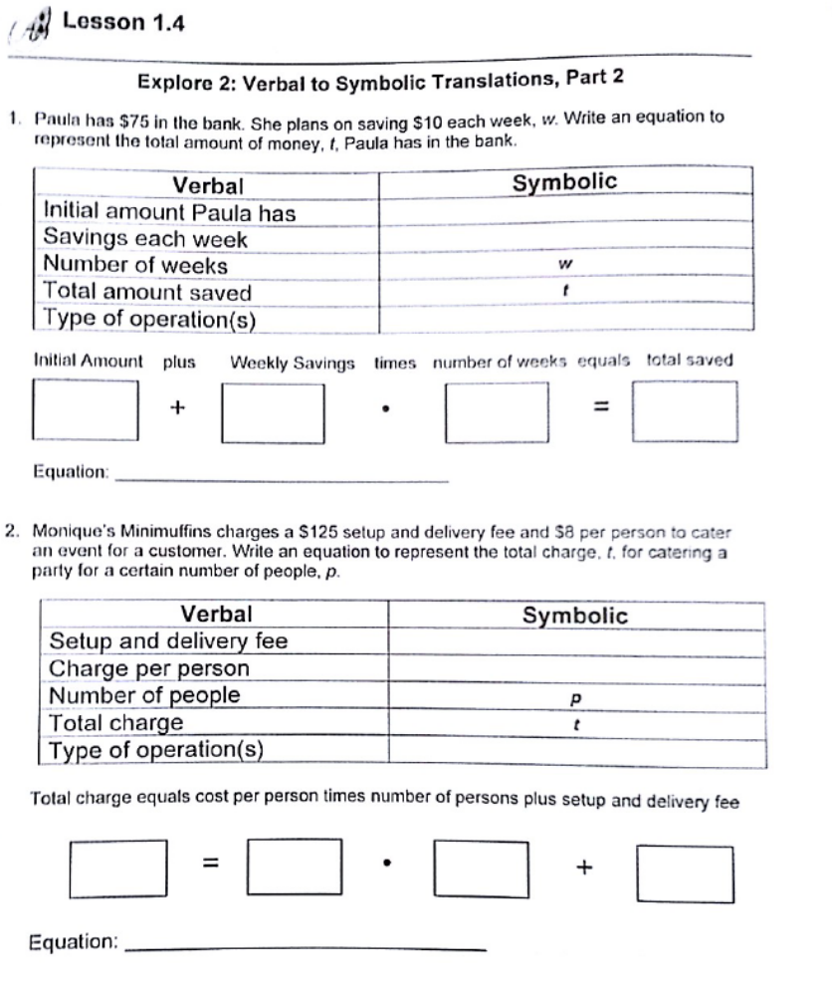

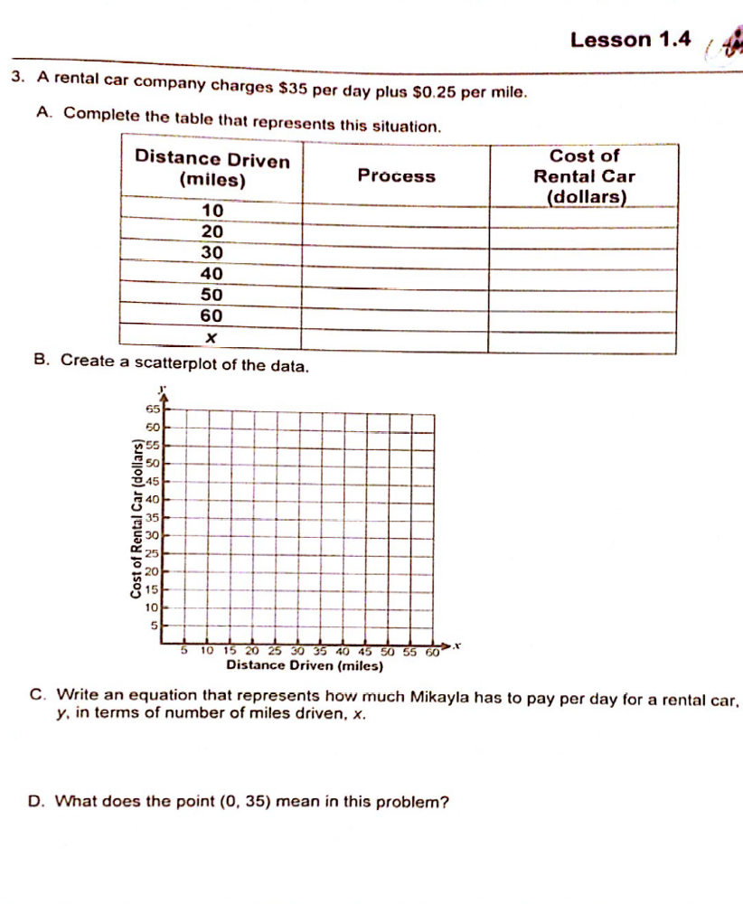
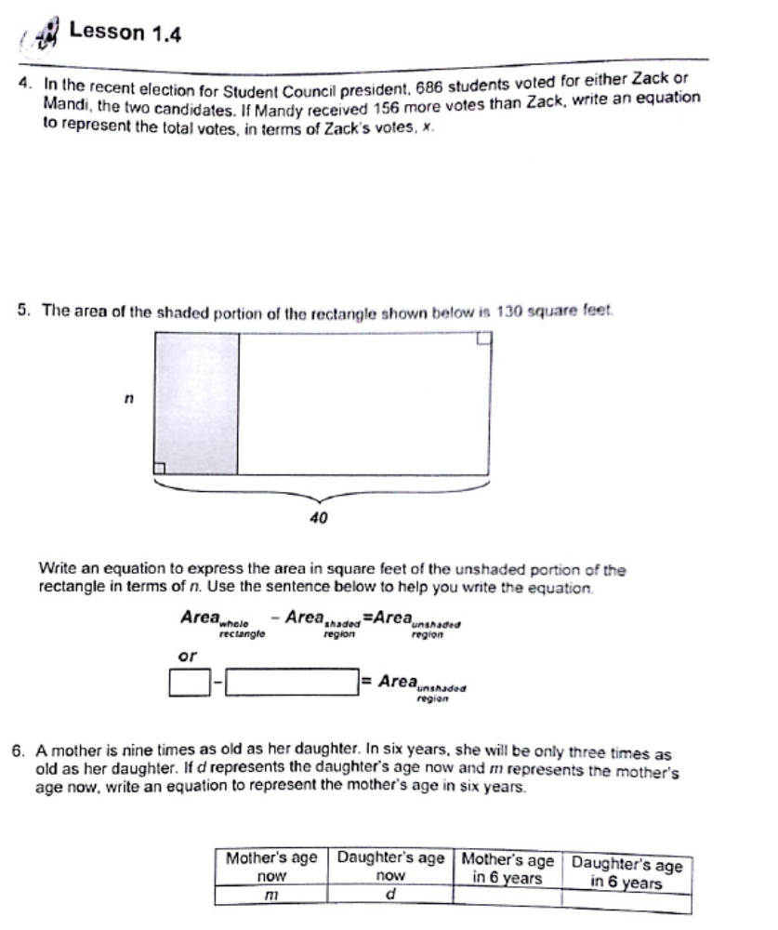
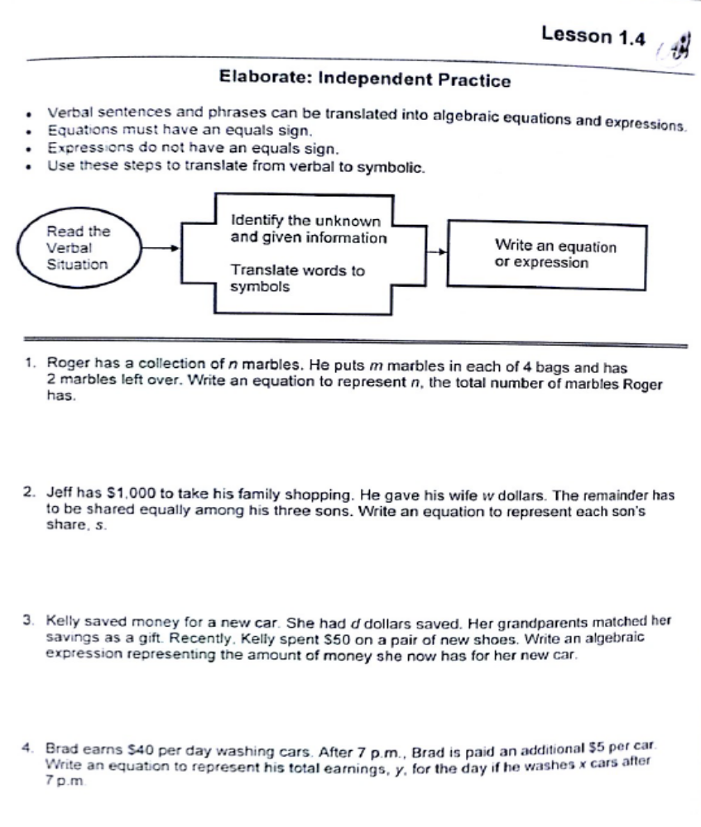
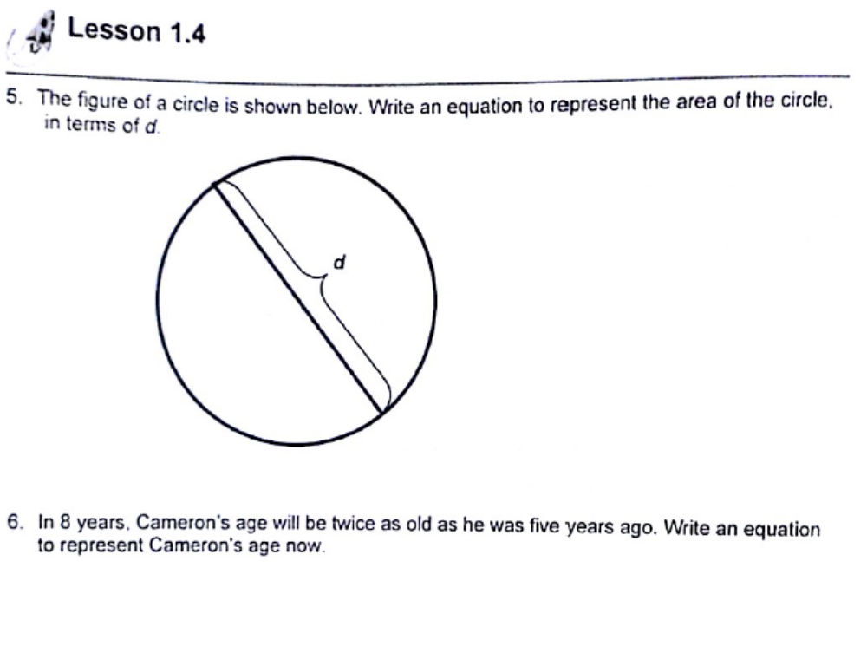
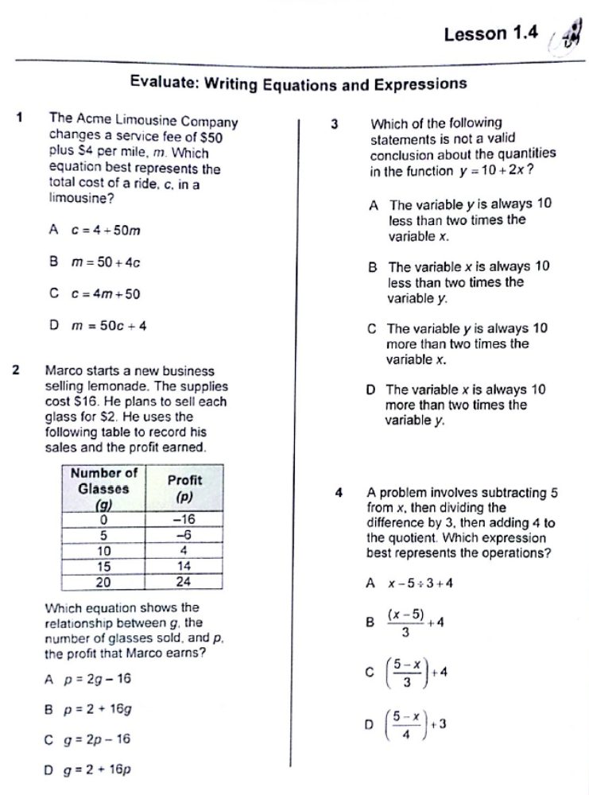

Translation Homework

1. Write a variable expression for the amount of money you would pay to join Northside Fitness, based on the number of months you belong to the club.
The Only
Health Club
That Meets
Your Needs!

No initiation
fee, and
your first
month is free!
North
SIDE

Just
$65
per month!

2. Chris says “I read a lot of books when I’m on vacation. I bet I read about two books a day. I also like to take a couple of extra books along.” Write a variable expression. What does the variable stand for?

Use the recipe below for questions 3 – 5.

3. Write a variable expression for the weight


How long to cook?

You should cook a turkey 20 minutes for each pound.

If the turkey is stuffed, add a half hour.

How many servings per pound?

For a whole turkey, allow 1.5 pounds per person.

This amount is roughly based on 4 oz servings of cooked turkey with some leftovers for sandwiches the next day.
Roast Turkey
of the turkey you should buy, based on the number of people who will be eating it.

4. Write a variable expression for the amount
of time in minutes you should cook a stuffed turkey, based on its weight.

5. When should you begin cooking a 16lb
stuffed turkey if you want to take it out of the oven at noon?

6. The area of a circle is 3. 7. The perimeter of a rectangle is 65.

8. The length of a rectangle 9. The circumference of a circle is 7.
is six less than three times
its width.

Describe a situation the variable expression could represent.

10. 20 + .15m

_________________________________________________________________________

_________________________________________________________________________

_________________________________________________________________________

_________________________________________________________________________

_________________________________________________________________________

11. 1.50m + 3.26k

_________________________________________________________________________

_________________________________________________________________________

_________________________________________________________________________

_________________________________________________________________________

_________________________________________________________________________

Alg. 1A Name_______________________________
Date _________________Period_________

Quiz: Order of Operations, Evaluating &Translation

Simplify the following using order of operations.

1. 8 – 9 · (-3) 2. 25 ÷ 5 + 2(7 + 3) 3. -39 ÷ |-13|

4. 1 – 9 · (-7) 5. 4 + 8 ÷ 2(5 – 9)

Evaluate the following expressions.
7. y² + 3y – 2 for y = 4 8. 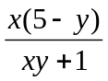 for x = -2, y = 69. 9. (-3x)² + 1 for x = 3

10. 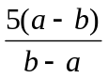 for a = -2, b = 2 11. 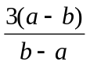 for a = 8, b = 11

For problems 11 – 15, translate each verbal expression into an algebraic expression.

11. The sum of 3 times a number and 4. __________________________________________

12. Twice a number divided by 16. _______________________________________

13. Five times a number squared. __________________________________________

14. 18 less than a number cubed. ________________________________________

